# CARE

|  |  |
| --- | --- |
| Supervisor. | **Miss** **Ramsha** |
| Batch. | **2310F1** |
| Group. | **A** |

|  |  |  |
| --- | --- | --- |
| Serial No. | Enrollment  Number | Student Name |
| **1.** | **Student 1525611** | Saba |
| **2.** | **Student 1521664** | Anmol Naz |
| **3.** | **Student 1521662** | Hafsa Abid Lodhi |
| **4.** | **Student1522516** | SHAH MIR HASSAN |
| **5.** | **Student1521525** | SYED JAWAD BUKHARI |
| **6.** | **Student1522512** | MUHAMMAD INSHAL MUSTAFA KHAN |

ACKNOWLEDGEMENT :

The first, we would like to express my special thanks of gratitude to my teacher <<Miss Ramsha>>, who helped us a lot in finalizing this project within the limited time frame, valuable counselling and assistance for the accomplishment of this project.

Secondly we would also like to thank the eProject team at Aptech Head Office, who gave us the golden opportunity to do this wonderful project about Care.

Thirdly, we also thank the eProject team, some of the benefits are as under:

* Re-enforcement of skills happens in the experiential learning process. 
* A mentor, ensuring that we do not get drifted, constantly guides us. 
* It gives us a lot of confidence to face an interview as we have worked on a project. We can explain virtually everything on the subject we have learnt. 

***SYNOPSIS***

With the rapid advancement of the internet, technology, and the healthcare industry, every hospital needs an efficient website design to display its services and offerings. Care’s hospital management system is designed with various interfaces and features, catering to diverse needs and preferences within the healthcare sector. The system includes customized tools that enhance patient management, appointment scheduling, and communication between healthcare providers and patients. The website allows users to explore these features and learn more about the comprehensive healthcare solutions offered by Care. However, service appointments and other transactions are handled directly through the hospital management system rather than on the website itself.

***PROBLEM DEFINITION***

Care, a leader in healthcare technology, offers a comprehensive hospital management system to streamline hospital operations and patient care. Traditionally, hospitals have relied on physical means of communication, such as leaflets, posters, and other media, to inform patients about their services. With the increasing shift toward digital solutions, Care has developed an online system with detailed information about hospital functionalities, patient services, and administrative processes. Key considerations we addressed include:

Designing an effective sitemap for easy navigation

Organizing essential information on each page to enhance clarity

Ensuring a user-friendly and welcoming comment section for feedback

Crafting an optimal user experience for ease of use

Meeting system requirements for smooth and reliable functionality

Facilitating direct contact between users and hospital staff for support and inquiries

This system provides a robust digital platform that connects patients and healthcare providers, making hospital services accessible to all.

CUSTOMER REQUIREMENT SPECIFICATION (CRS)

Here's a revised version focused on a hospital management system with backend requirements:

After detailed discussions, we defined the specifications for building a comprehensive website for Care's hospital management system, covering both frontend and backend requirements:

**Frontend:**

**Home Page:** The homepage will feature a professional logo and a cohesive color scheme, ensuring a clean and engaging user experience.

**Navigation Menu:** The menu will offer easy access to sections like "Services," "Technology," "Facility Locator," "Patient Support," etc., for seamless navigation.

**Service Information Pages:** Each page will provide details on various healthcare services, advanced technologies used in patient care, and specialized departments.

**Service Categories:** Information will be organized by category, such as "Emergency Services," "Outpatient Care," "Surgical Services," etc., for easy access and clarity.

**Service Selection and Details:** When a user selects a specific service category, a list of related services will be displayed. Each service page will include a title and in-depth description, with additional documents available for download.

**Pricing Information:** A downloadable price list for healthcare services will be provided to enhance patient transparency.

**Contact Us Page:** The “Contact Us” page will feature the addresses of Care facilities, email links that open in the user's default mail client, and location data using a Geolocation API (e.g., Google Maps) for easy navigation.

**Backend:**

**Database Management:** A secure backend database will store all data, including patient records, service information, pricing, user feedback, and contact details. The database will be designed for efficient storage, etrieval, and security.

**User Authentication:** Secure login functionality will be implemented for staff and patients to access different levels of information. Patient and staff profiles will be stored and managed through secure sessions.

**Service Content Management:** An admin dashboard will enable Care administrators to manage content, such as updating service information, uploading documents, and managing price lists.

**Document Storage and Access:** The backend will manage file uploads for downloadable documents (e.g., service details, pricing lists) and ensure these are securely stored and accessible on-demand.

**Email Integration:** The system will enable email triggers for inquiries submitted through the "Contact Us" form, connecting directly to Care's customer service.

**API Integration:** Integrate a Geolocation API (e.g., Google Maps) to display facility locations accurately on the "Contact Us" page.

**Feedback and Support System:** A backend system will manage user comments and feedback to ensure a responsive patient support experience.

This setup will create an intuitive and responsive website for Care's hospital management system, providing patients and administrators a seamless experience on both frontend and backend levels.

SCOPE OF THE WORK (IN *BRIEF*)

The hospital management system website is to be developed for the Windows platform using HTML5, JavaScript, Php The website will be compatible across all leading browsers, including Chrome, Edge, Firefox, and Safari, ensuring a seamless experience for users.

**Frontend Specifications:**

**Homepage:** The homepage will feature essential healthcare highlights such as top services, recent health campaigns, ongoing medical programs, and new department or service launches. Each section will link directly to relevant content for easy access.

**Responsive Design:** The website will adapt to various screen sizes, from desktop to mobile, providing a consistent experience across devices.

**Geolocation Services:** The site will integrate Geolocation API to show the nearest Care facilities to the user, improving accessibility for patients seeking hospital locations.

**Browser Compatibility:** The site will be optimized to perform well on all major browsers, including Chrome, Edge, Firefox, and Safari.

**Backend Specifications:**

**Database Management:** A robust SQL or NoSQL database will store patient data, service details, department information, and user inquiries, ensuring secure and efficient data handling. This will also support scalability as the hospital’s services grow.

**Content Management System (CMS):** An admin dashboard will be created for hospital staff to manage and update key content, including adding new services, updating top services on the homepage, managing health campaign details, and updating contact information.

**User Authentication and Profiles:** Secure user authentication will enable patients, staff, and administrators to access their respective profiles, with personalized data storage for patients, allowing them to access their medical history, appointments, and billing information.

**Document and Media Management:** The backend will support uploading, storing, and managing various documents, such as downloadable patient forms, medical brochures, and pricing information, all accessible via secure links on the website.

**Patient Feedback System:** A backend module will collect and manage patient feedback submitted on the website, providing healthcare administrators insights into patient experience.

**Analytics and Reporting:** The backend will track website traffic, popular services, and patient interactions, offering insights through reports that help improve patient service delivery.

This system will create a seamless experience for patients, staff, and administrators by delivering intuitive frontend interfaces supported by a powerful backend infrastructure for Care’s hospital management system.

WIREFRAME

**1. INDEX PAGE:**

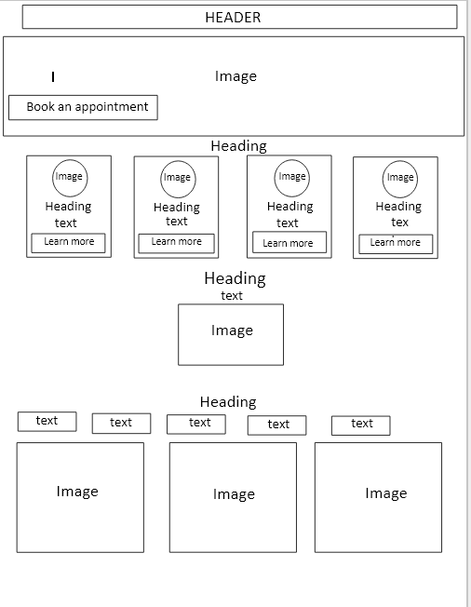

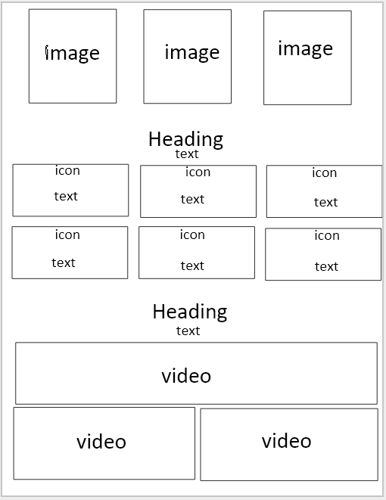

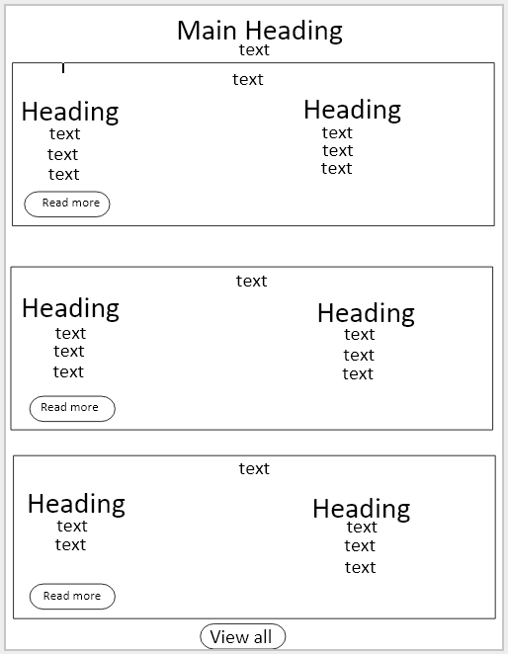

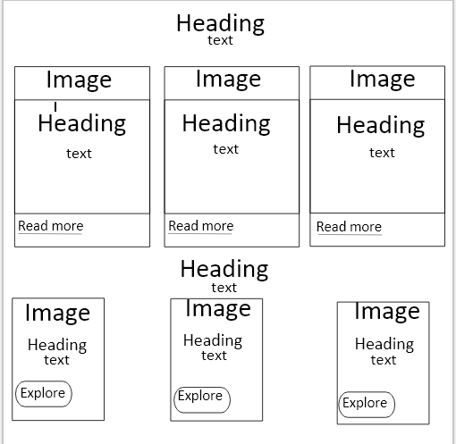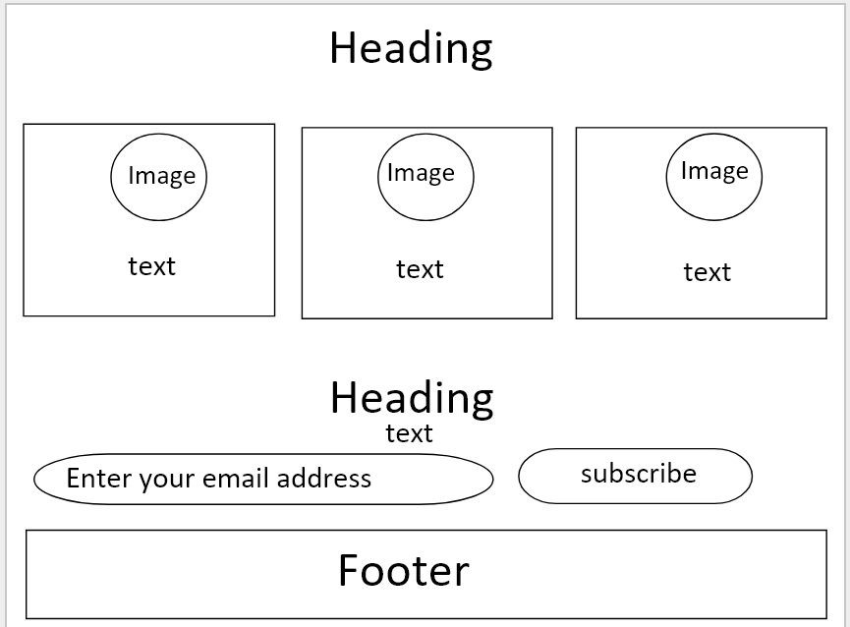

**2. Contact us:**

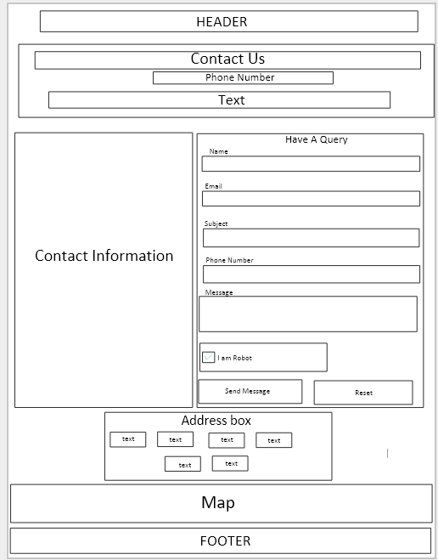

**Backend Wireframe**

Patient view_profile

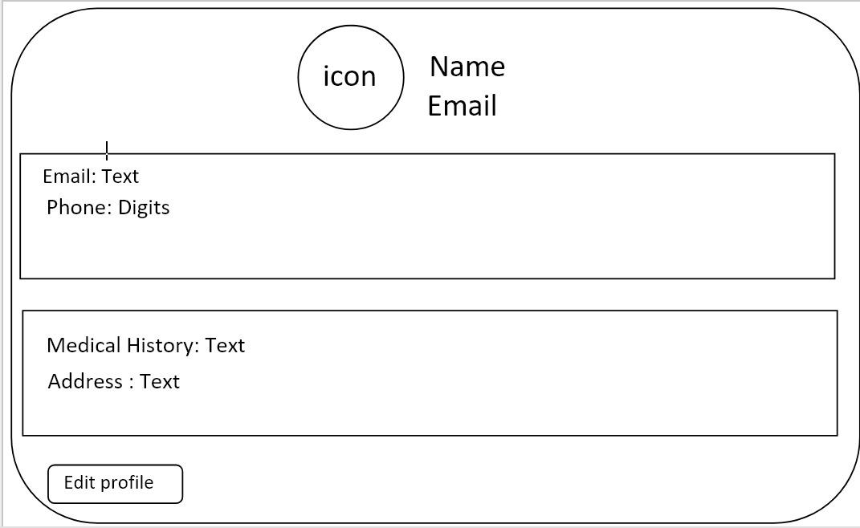

patient edit_profile

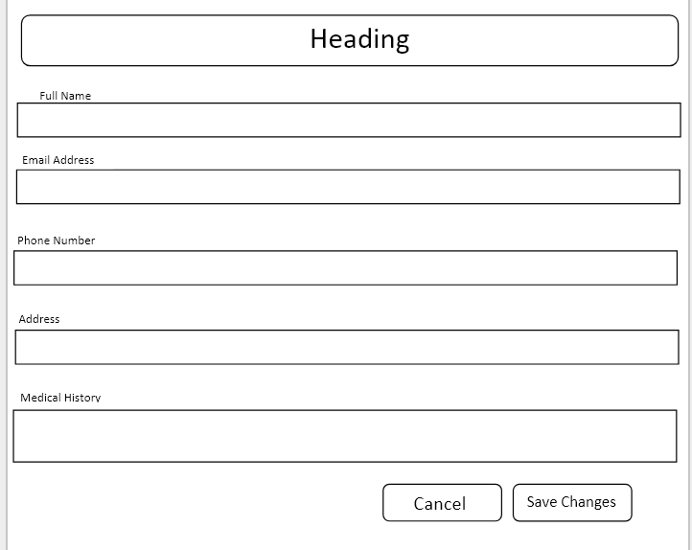

****Doctor view_profile****

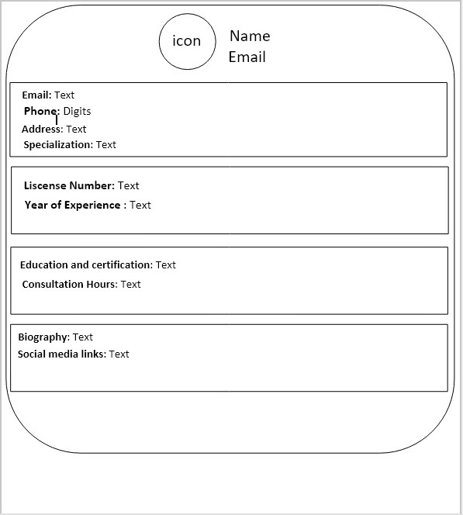

Search Doctors

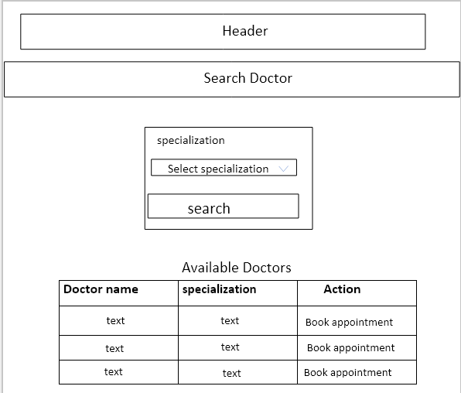

Admin_page Dashboard

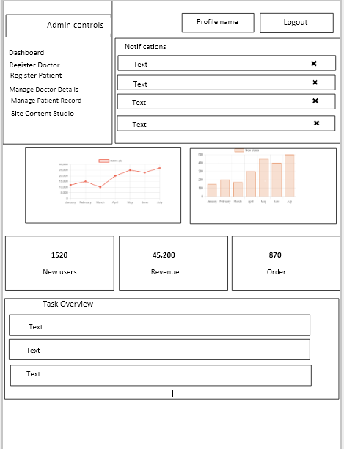

Doctor page dashboard

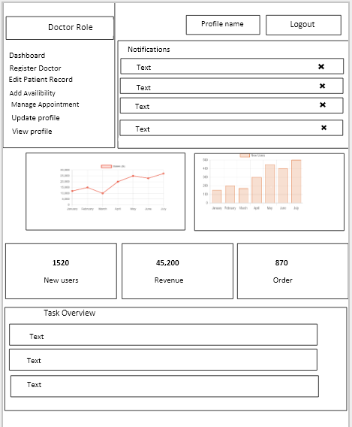

USER PANEL

HEADER:

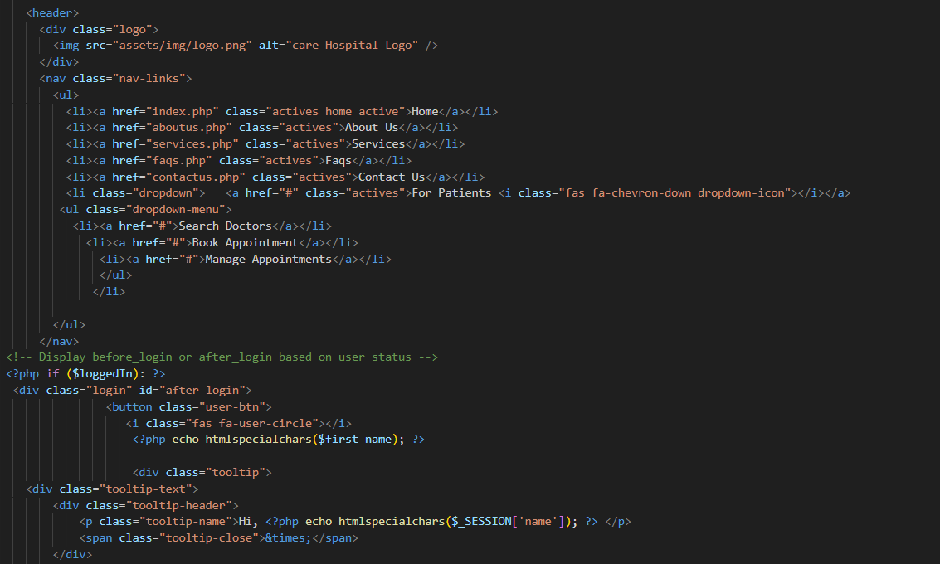

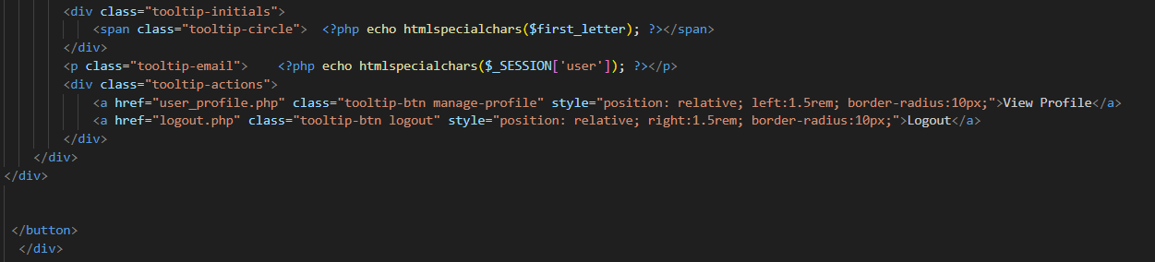

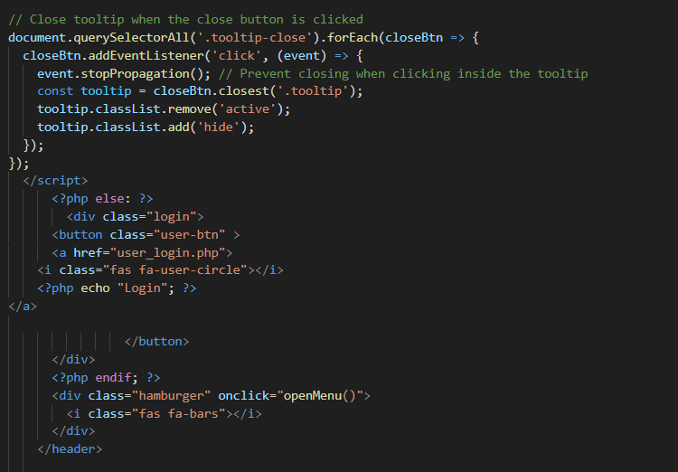

This code is a header section for a hospital management website called "Care." It includes a logo, a navigation menu with links to various pages like "Home," "About Us," "Services," and "Contact Us," as well as a dropdown menu for patient-related options (e.g., searching doctors and managing appointments). If the user is logged in, their name and profile options are displayed with a tooltip for quick access to their profile and logout options. It also includes a responsive hamburger menu for smaller screens, toggling a fullscreen menu that mirrors the main navigation options and adapts based on login status.

BANNER

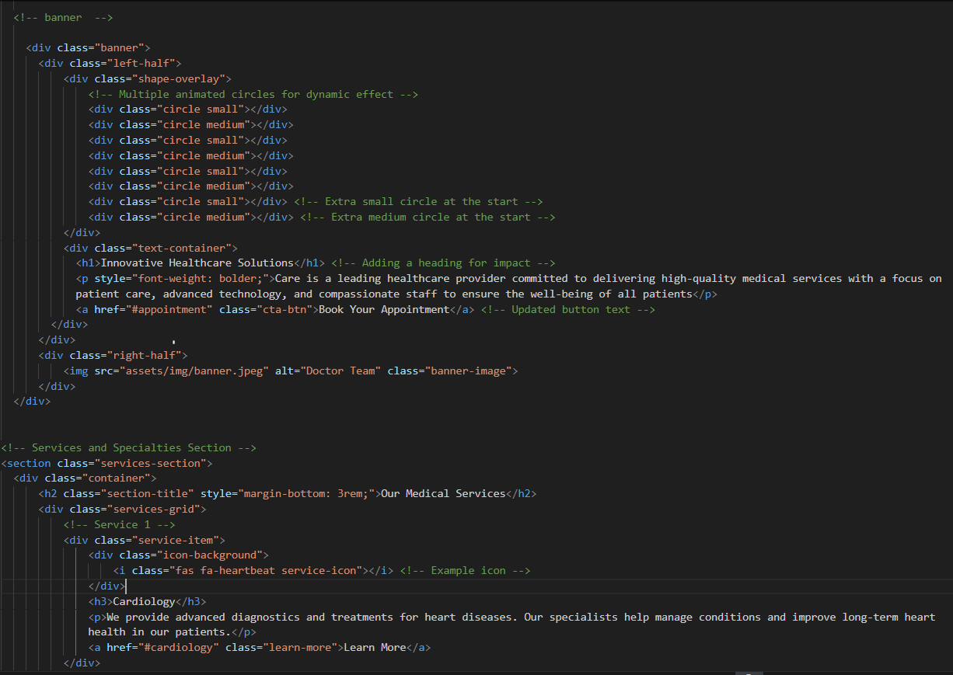

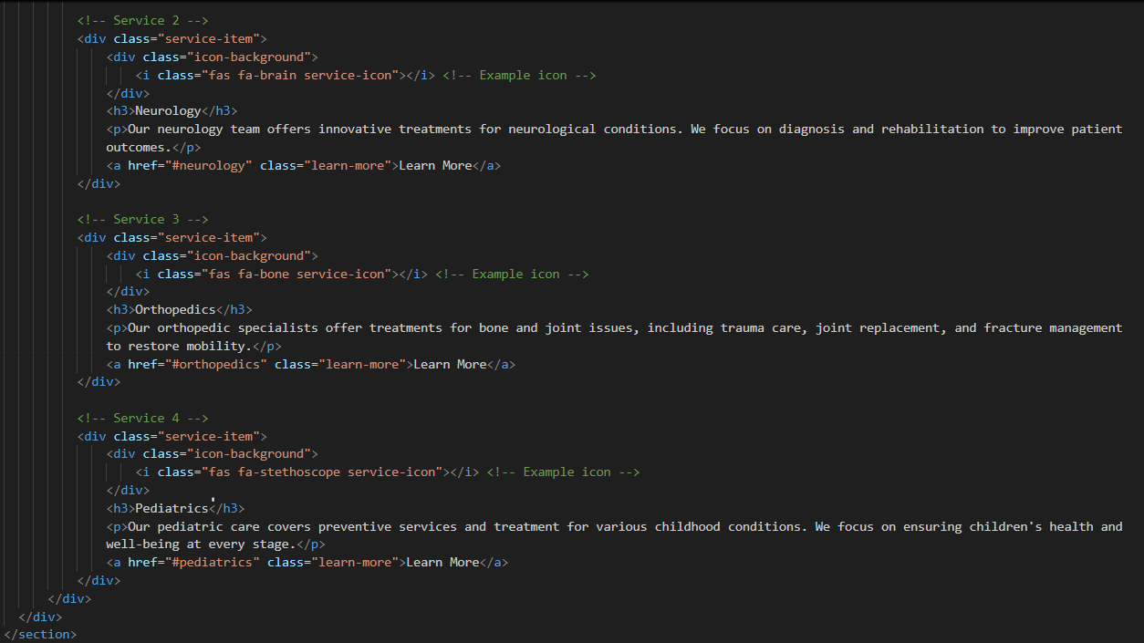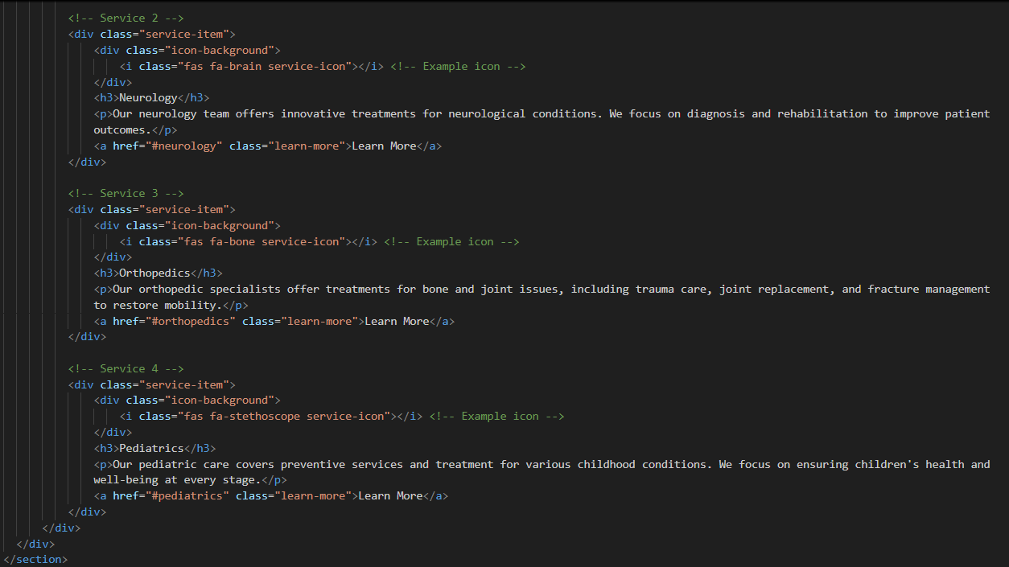

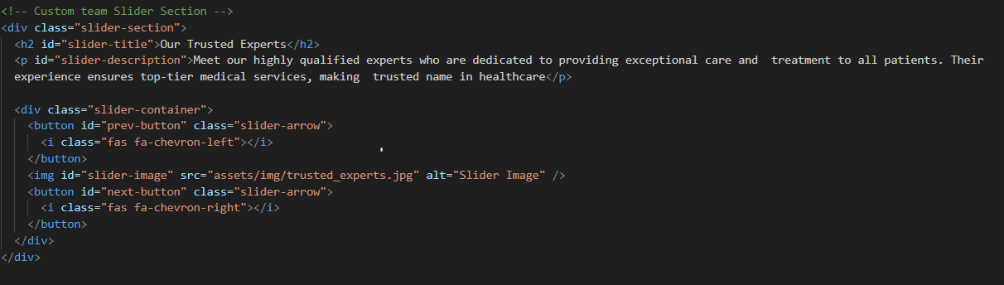

This HTML code creates a comprehensive hospital website layout featuring multiple sections. It begins with a banner, displaying a "Book Your Appointment" call-to-action, a heading, and dynamic circle animations for visual appeal. The "Services and Specialties" section highlights key medical services such as Cardiology, Neurology, Orthopedics, and Pediatrics. It also includes a "Trusted Experts" slider to showcase the hospital's professional team and a gallery section with categorized images. Finally, the "Why Choose Us" section presents key advantages, such as experienced staff, advanced technology, and affordable care, to strengthen trust with prospective patients.

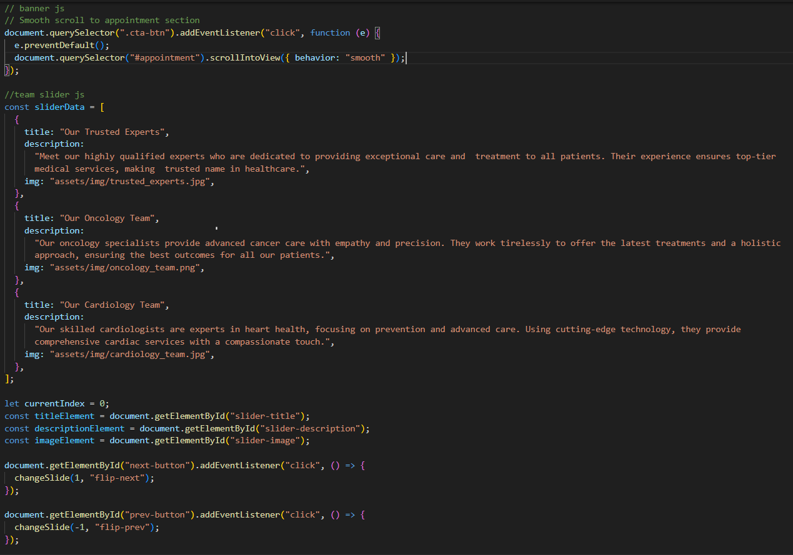

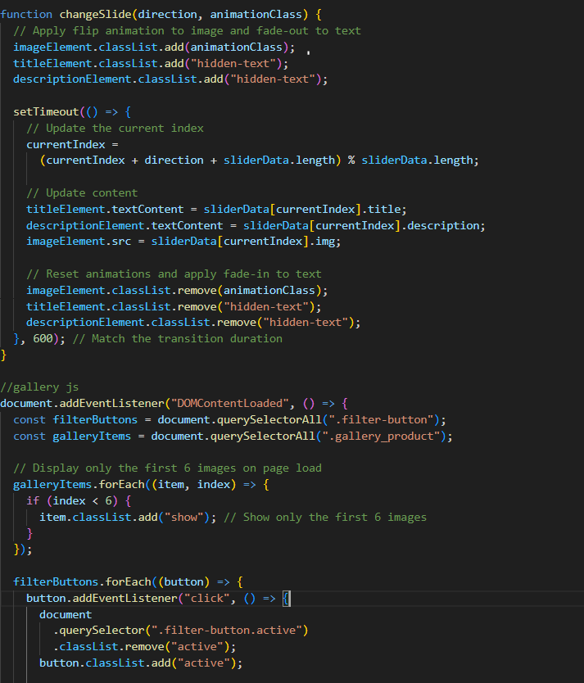

This JavaScript code includes a smooth scrolling effect and a team slider functionality for a healthcare website. The first part listens for clicks on a button with the class .cta-btn, scrolling smoothly to the "appointment" section on the page. The slider Data array contains details for the team slider, including titles, descriptions, and image paths for each team, such as "Our Trusted Experts," "Our Oncology Team," and "Our Cardiology Team." The slider allows navigation through the team profiles using "next" and "previous" buttons, updating the displayed title, description, and image.

ABOUT US:

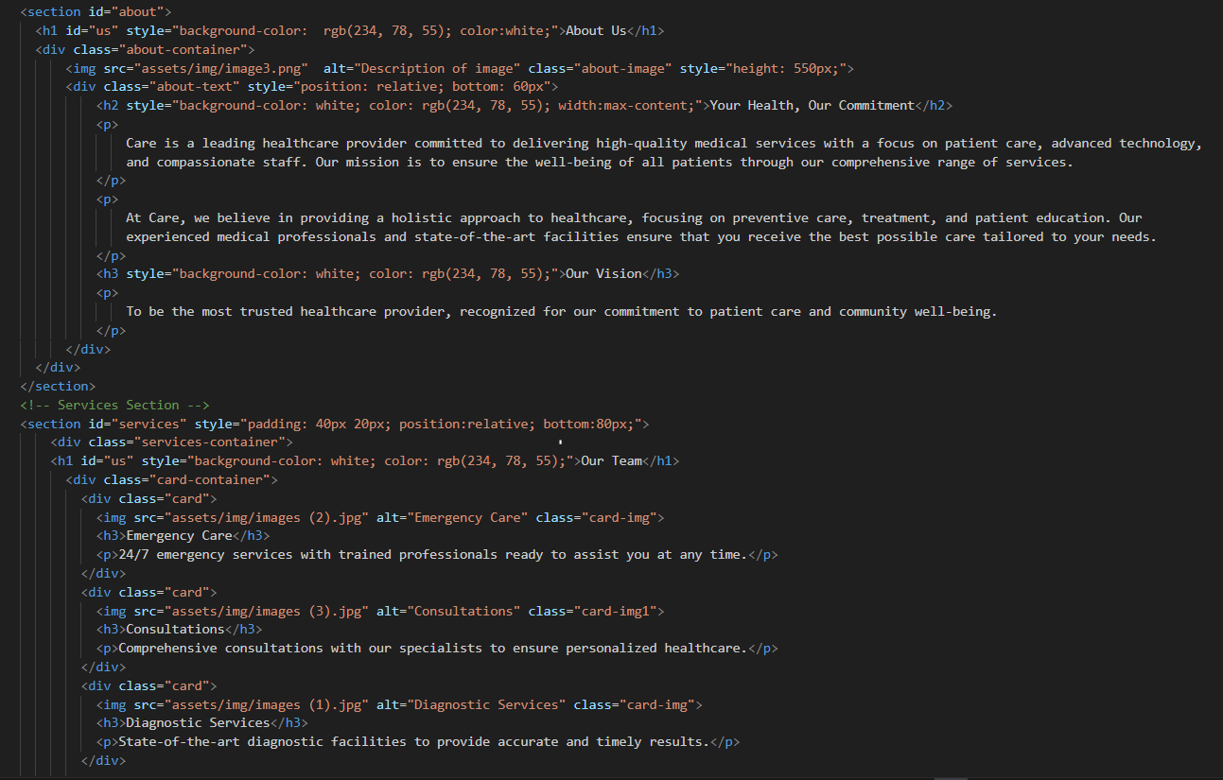

This HTML structure defines an "About Us" section with a mission-focused layout. It includes a heading, image, and descriptive text highlighting the healthcare provider's dedication to high-quality medical services, patient care, and advanced technology. The "Our Vision" section outlines the goal of becoming the most trusted healthcare provider. Additionally, there's a "Services" section featuring cards for "Emergency Care," "Consultations," and "Diagnostic Services," each with an image and brief description. A modal window is also present for displaying additional details when needed.

FAQS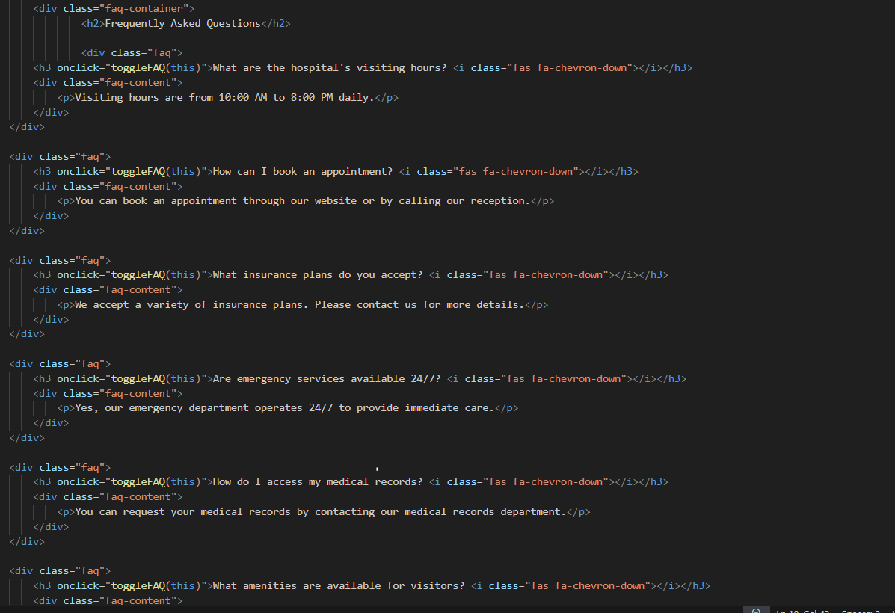

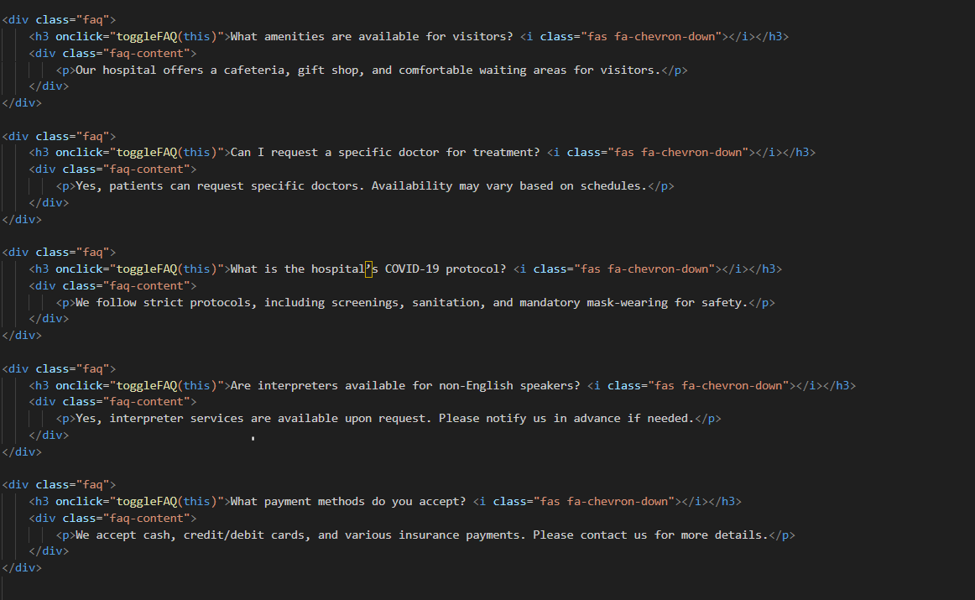

This HTML section provides a "Frequently Asked Questions" (FAQs) area, offering answers to common inquiries related to the hospital's services and policies. Each FAQ item has a question that can be expanded to reveal more information, such as visiting hours, appointment booking procedures, accepted insurance plans, and COVID-19 protocols. This interactive section, with a toggle functionality triggered by clicking on each question, enhances the user experience by making it easy to access key information.

SERVICES:

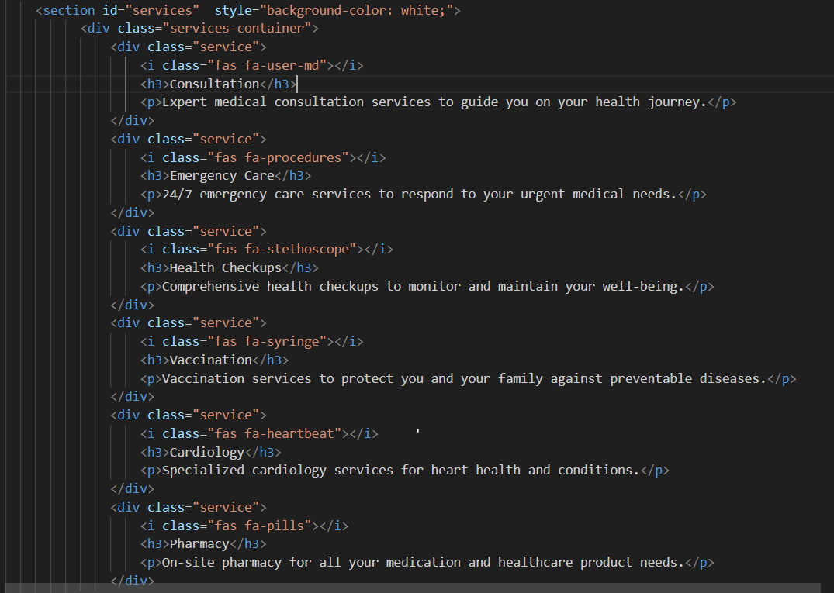

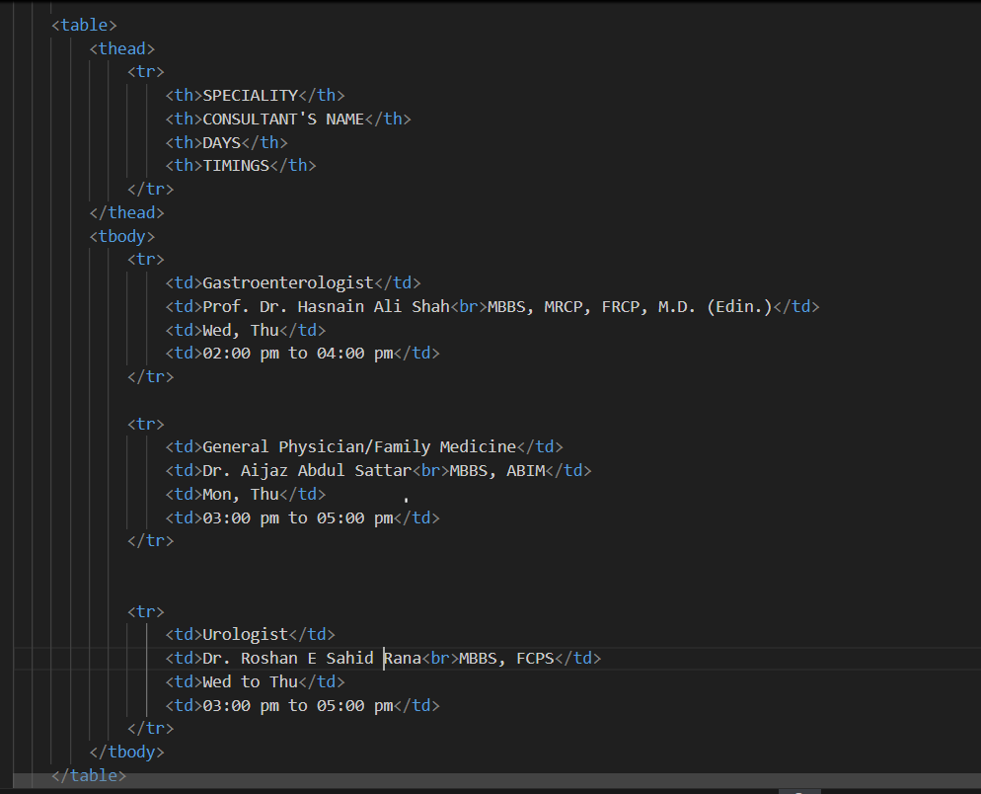

This page provides detailed information about various healthcare services offered, including consultation, emergency care, health checkups, vaccination, and more. It also includes specific doctor schedules, listing specialists in areas such as general medicine, rehabilitation, clinical psychology, occupational therapy, dermatology, and bariatric surgery. Each table outlines doctors’ qualifications, available days, and timings, allowing patients to easily plan appointments.

CONTACT US

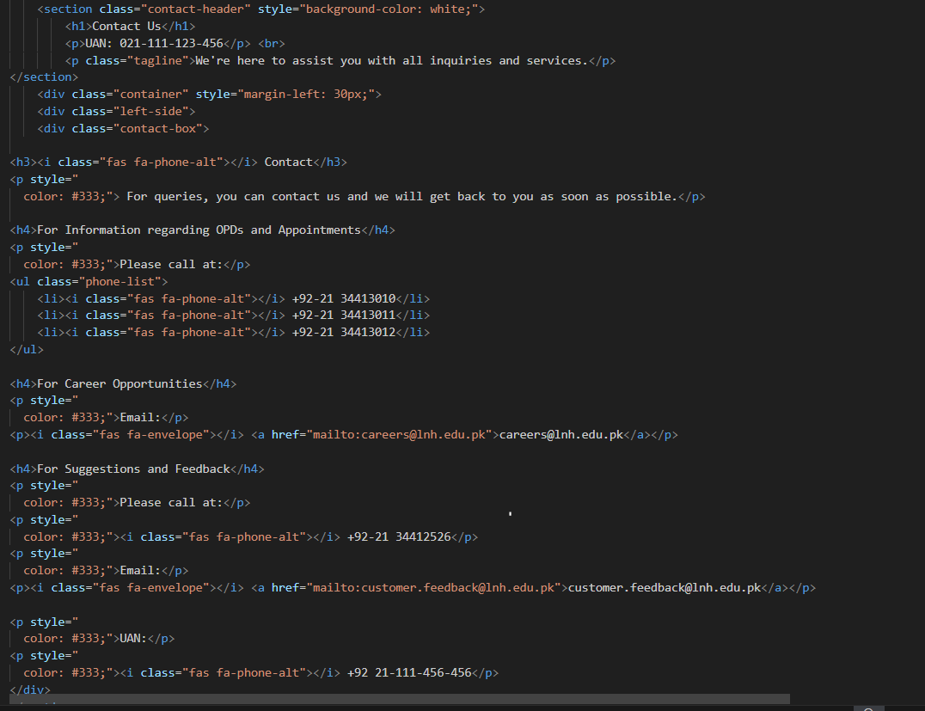

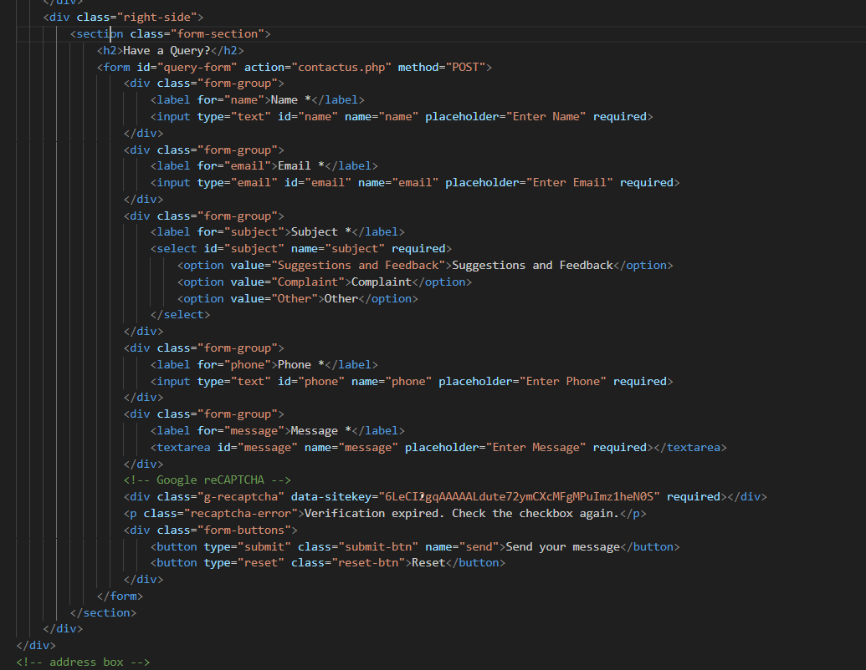

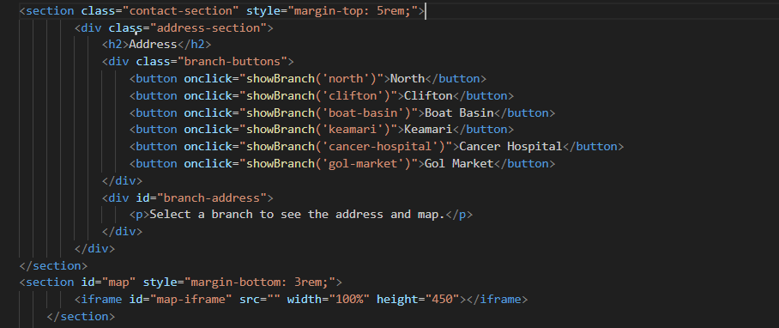

This contact page provides multiple ways for patients and visitors to connect with the hospital. It includes important contact numbers for appointment inquiries, career opportunities, and feedback. Additionally, there’s a structured contact form for users to submit queries directly, specifying their name, email, subject, and message. The section also provides options for branch selection, allowing users to view specific addresses and locations on a map. The integrated map feature ensures easy navigation, making it convenient for visitors to find the most relevant hospital branch.

FOOTER

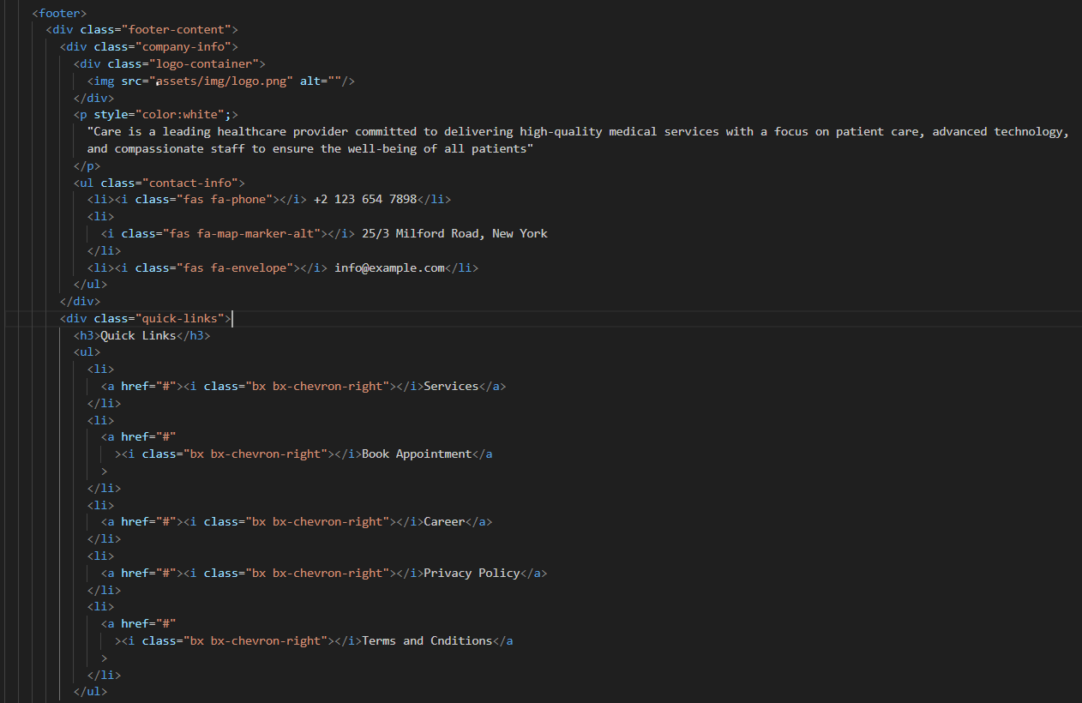

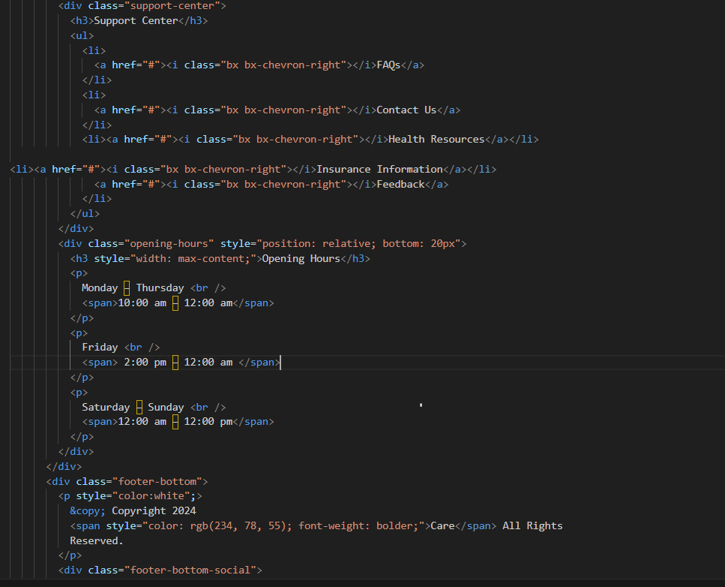

This footer section provides essential information about *Care*, a leading healthcare provider dedicated to patient-centered, high-quality medical services. It includes contact details, a brief description of the company's mission, and quick links to services, appointments, careers, and policies. The support center offers easy access to FAQs, health resources, and insurance information. Opening hours are clearly displayed, ensuring visitors know when services are available. The footer also includes social media links, enabling users to connect with *Care* on multiple platforms.

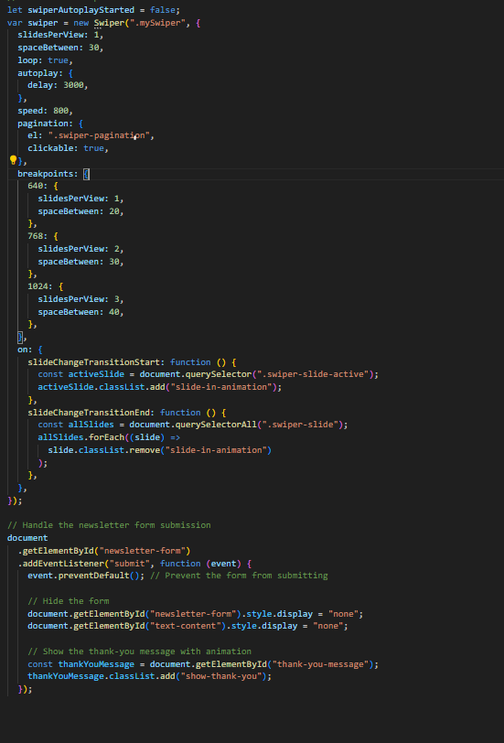

This JavaScript code initializes a Swiper carousel with autoplay, loop, and pagination features. It adjusts the number of slides visible and the spacing between them based on screen size breakpoints (640px, 768px, and 1024px). Transition animations are added and removed as slides change. Additionally, it handles a newsletter form submission, preventing the default form submission behavior, hiding the form and content, and showing a thank-you message with animation.

USER_REGISTER

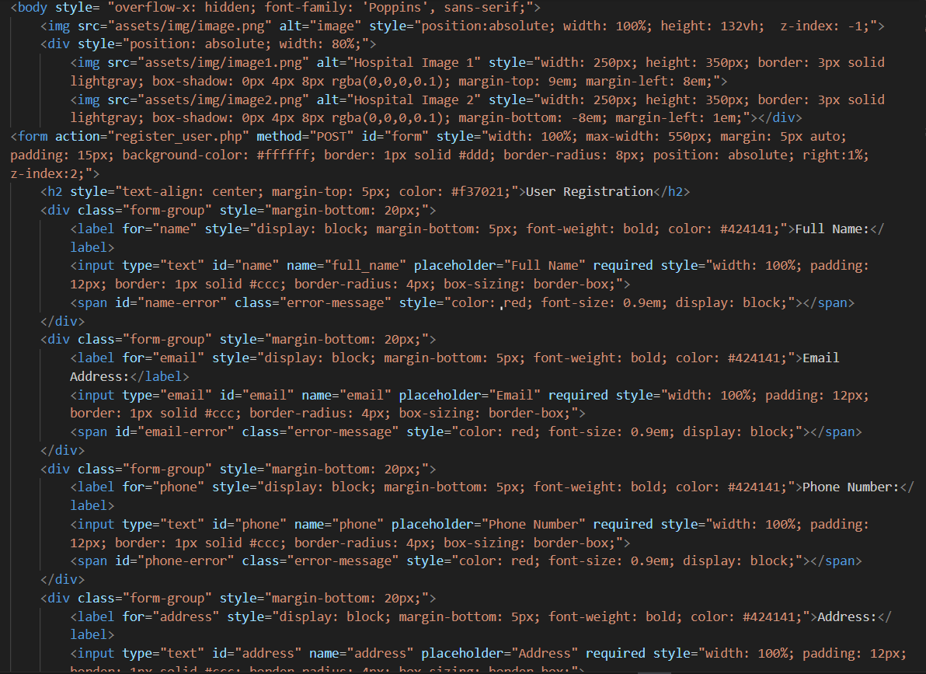

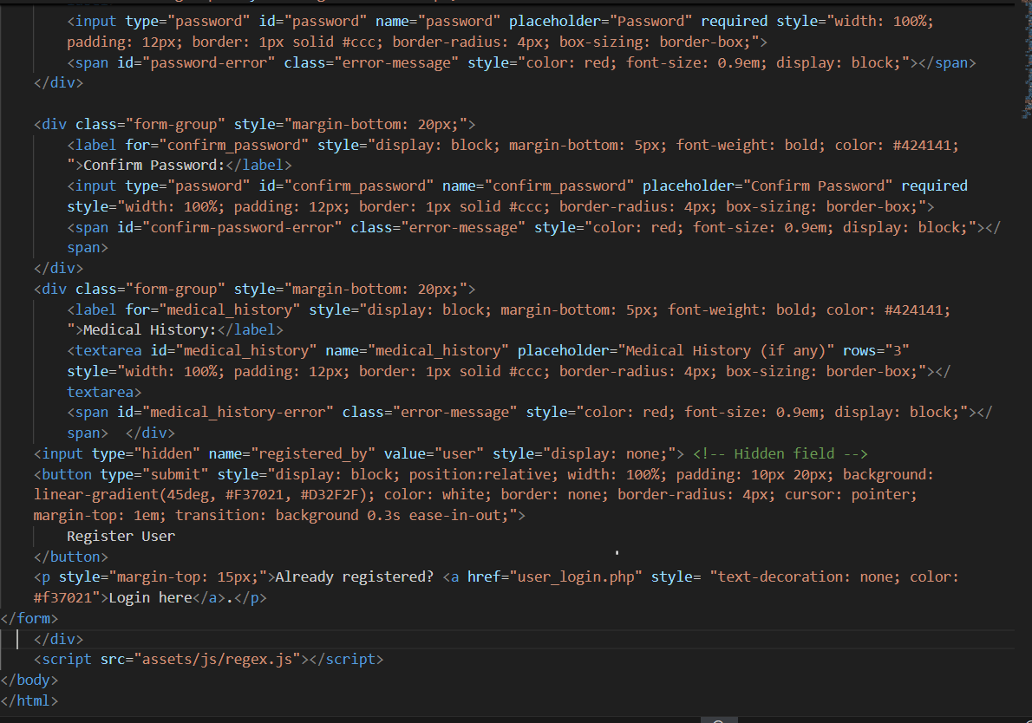

The provided HTML code creates a user registration page for a hospital management system. It features a full-screen background image and two hospital-related images positioned above a registration form. The form collects essential user information, including full name, email, phone number, address, password, and medical history, ensuring a user-friendly interface with clear labels and error message placeholders. Additionally, the form includes a visually appealing "Register User" button and a link for existing users to log in. Overall, it combines functionality with a clean, modern design.

USER_LOGIN

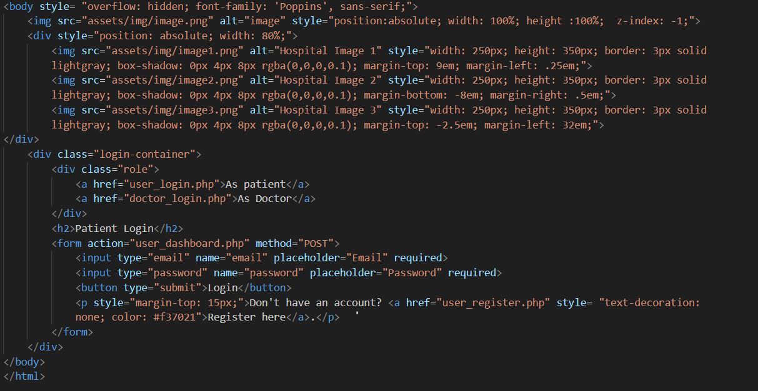

The code features a full-screen background image with three hospital images overlaying it, styled with borders and shadows for a polished look. In the foreground, a login container allows users to access the patient or doctor login pages, highlighted by a "Patient Login" heading. The form includes fields for email and password, along with a submit button, and provides a link for new users to register. The layout balances aesthetics and functionality, making it user-friendly.

USER_PROFILE

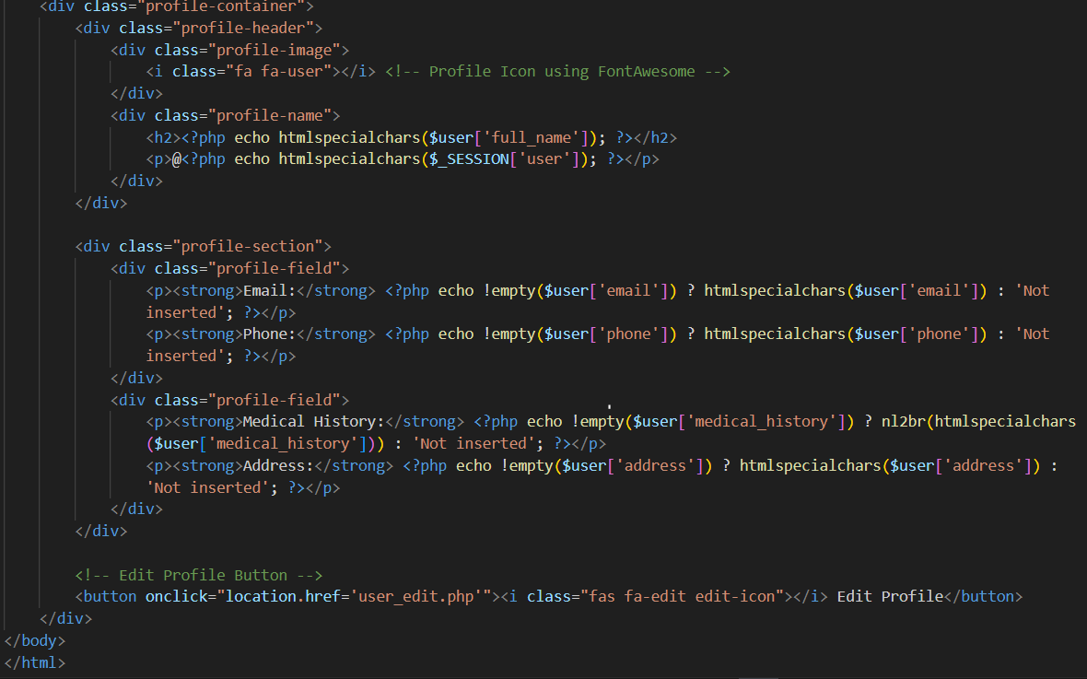

The code defines a user profile container displaying a profile header with an icon, the user's full name, and username. It includes sections for personal details such as email, phone number, medical history, and address, each showing appropriate placeholders if data is missing. An "Edit Profile" button allows users to navigate to a page for making changes to their information.

ADMIN_PANEL

ADMIN_DASHBOARD

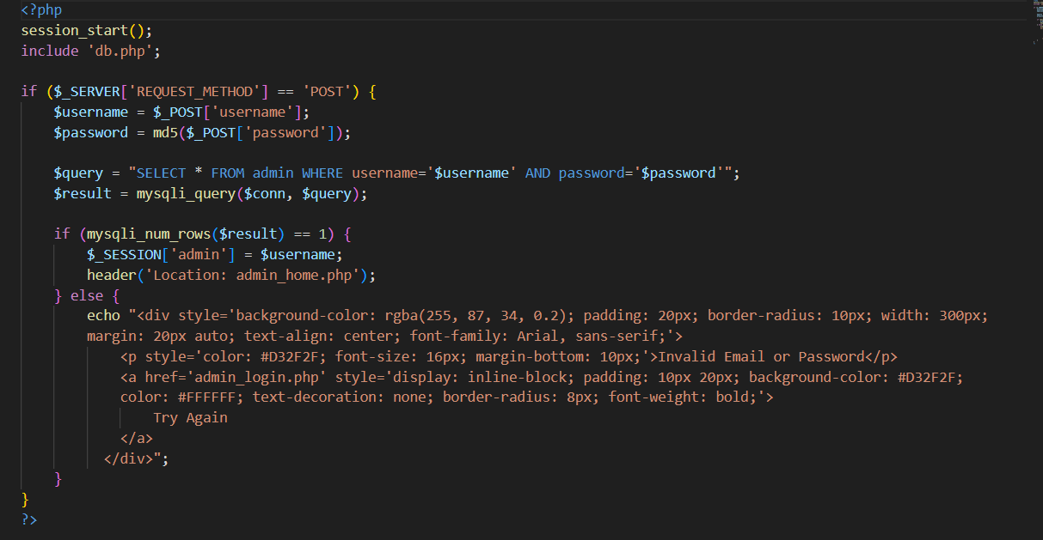

This PHP script handles admin login functionality. Upon receiving a POST request, it retrieves the username and password, hashing the password with MD5 for security. The script checks the credentials against a database, and if valid, it initiates a session and redirects to the admin page. If the login fails, it displays an error message with a link to retry the login.

ADMIN_LOGIN

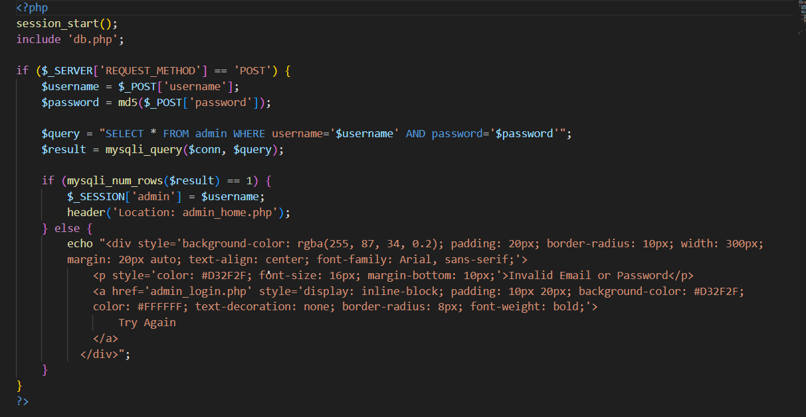

This code snippet presents an admin login interface featuring a background image and a welcoming header. It includes a form for username and password input, with a submit button to log in and access the admin dashboard. The layout is designed to be user-friendly and visually appealing for efficient navigation.

ADMIN EDIT_DOCTOR

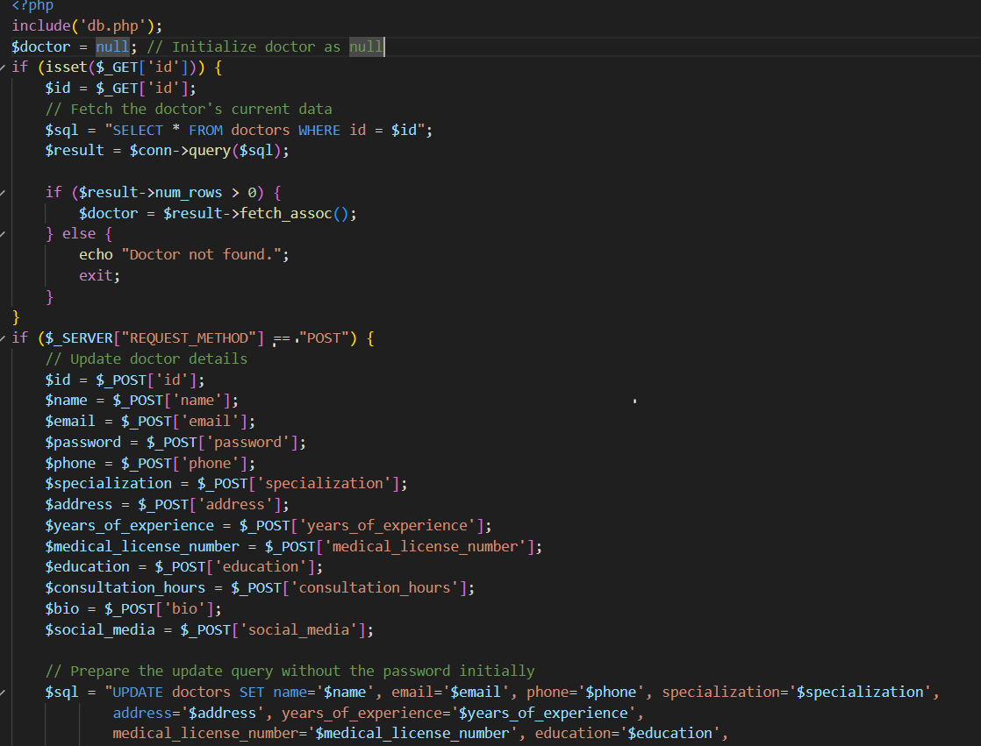

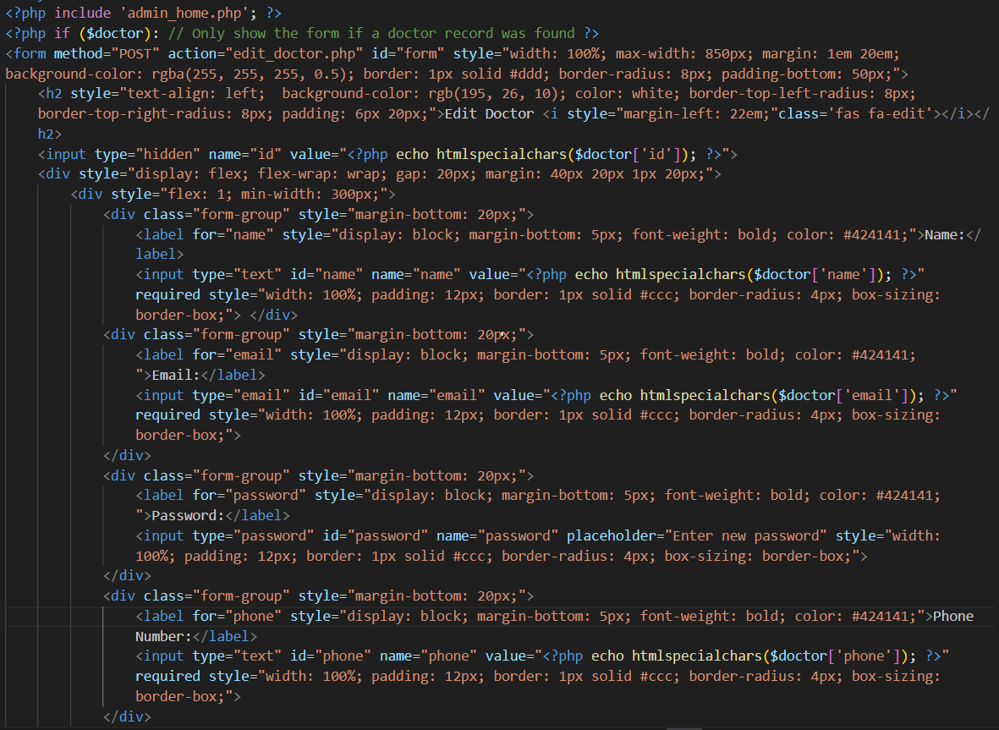

This PHP code snippet renders an editable form for doctor details, which appears only if a specific doctor's record is found. The form, styled with a semi-transparent background and clear labels, allows the admin to update various fields, including name, email, phone number, specialization, and biography, among others. Each input field is pre-filled with the doctor's existing information, and the form includes buttons for submitting changes or canceling the action, enhancing usability for efficient data management.

Top of Form

Top of Form

ADMIN EDIT_PATIENT

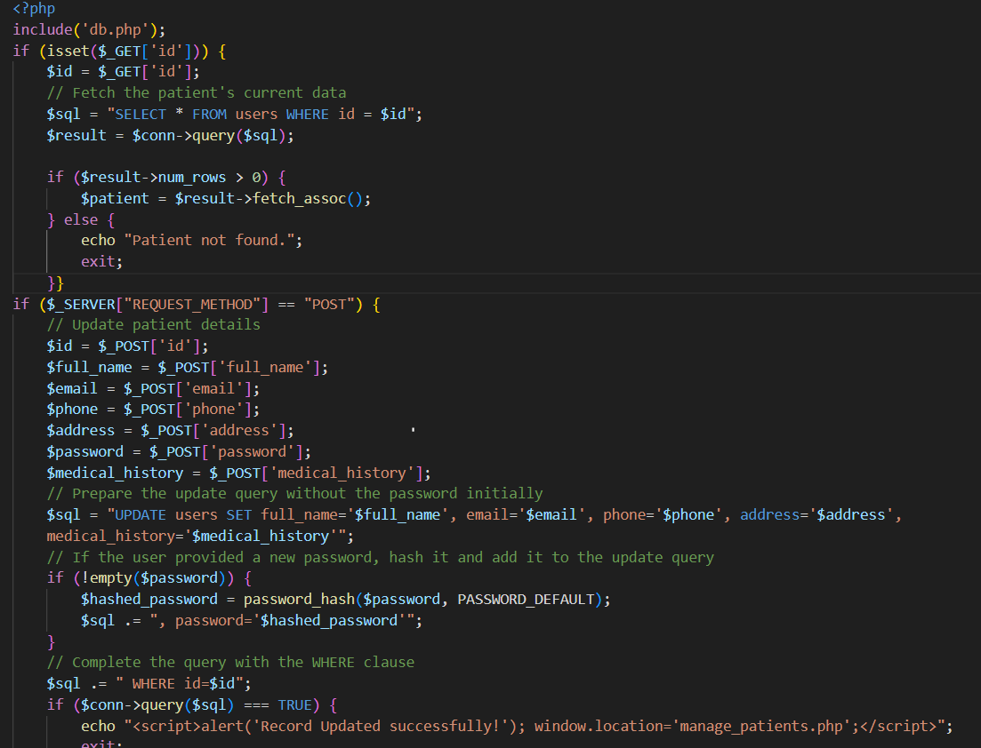

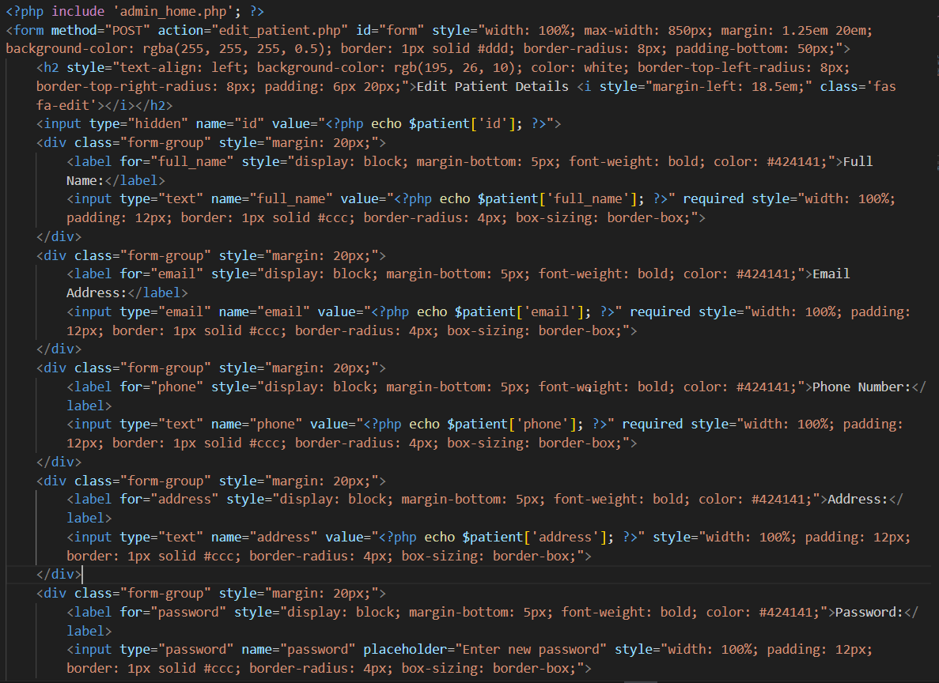

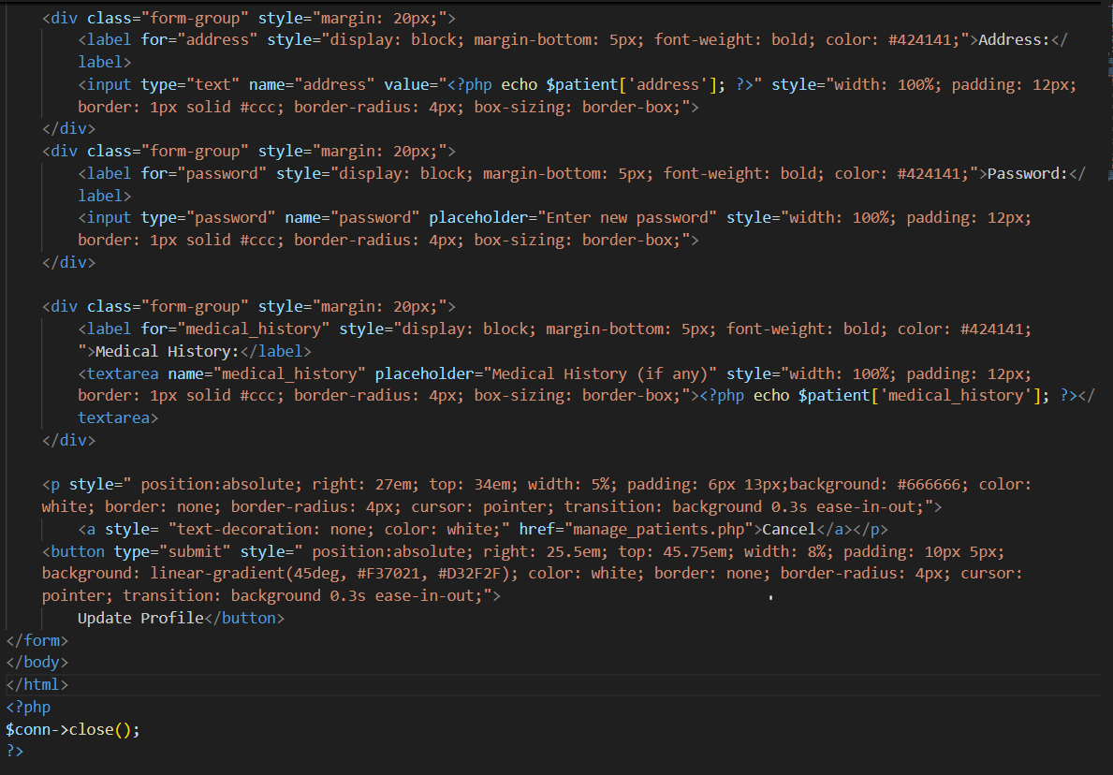

This PHP form allows an admin to edit patient details, featuring fields for the patient's full name, email address, phone number, address, password, and medical history. Each field is pre-filled with the existing patient data for easy updating. The form is styled with a light background and clear labels, and includes buttons to submit the updated information or cancel the action, providing a user-friendly interface for managing patient records.

ADMIN DELETE_DISEASE

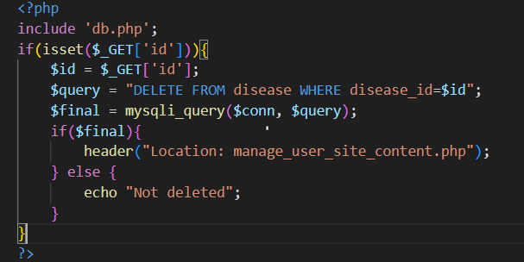

This PHP script connects to a database to delete a disease record from a table named disease. If an id is passed as a GET parameter, it is used to identify the disease_id for deletion. If the deletion is successful, the user is redirected to the manage_user_site_content.php page; otherwise, an error message "Not deleted" is displayed.

ADMIN MANAGE_DOCTOR

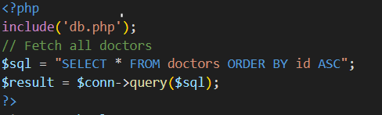

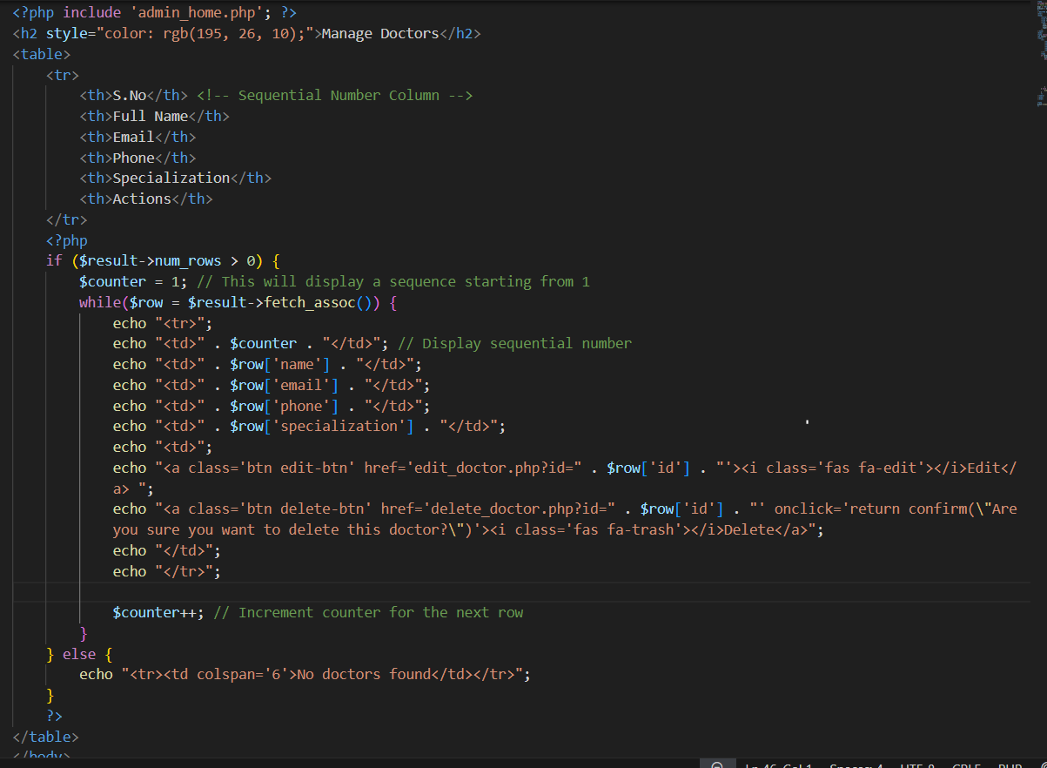

This PHP and HTML code displays a "Manage Doctors" section with a table listing doctors' details, including full name, email, phone, and specialization. Each doctor entry has actions to edit or delete their record, with sequential numbering for easy reference. If no doctors are found, a message displays indicating an empty table.

ADMIN REGISTER_DOCTOR

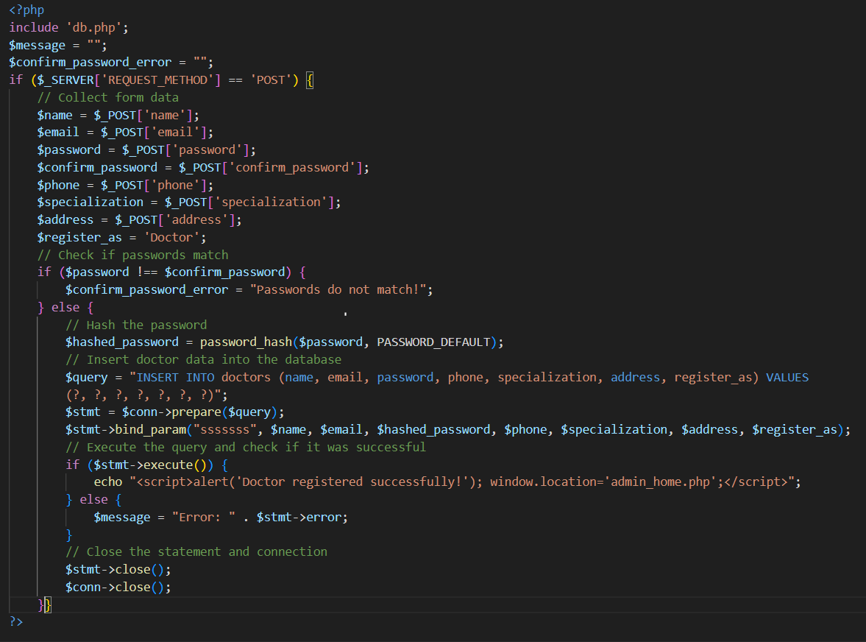

This PHP code handles doctor registration by collecting form data (name, email, password, phone, specialization, address), verifying password confirmation, and securely storing data in the doctors table with a hashed password. If registration succeeds, the user is redirected to admin_page.php with a success alert. If an error occurs, it displays an error message.

ADMIN REGISTER_USER

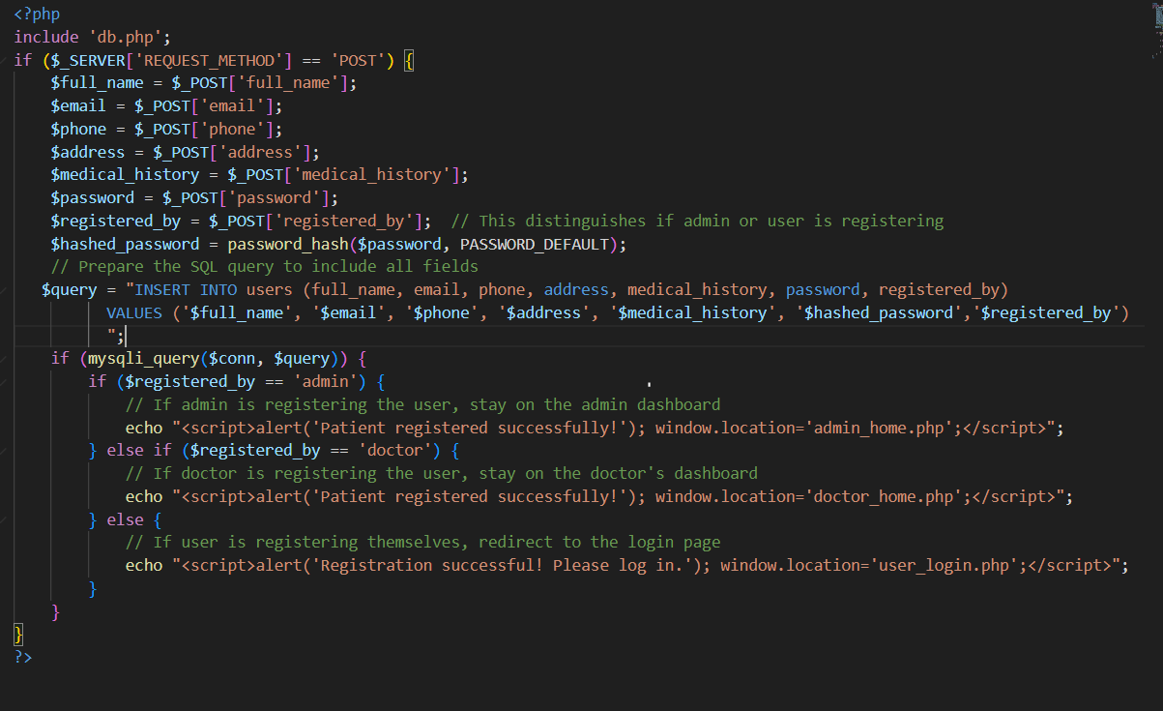

This PHP code registers a new patient by capturing details like name, email, phone, address, and medical history, and hashing the password before storing it in the users table. The registered_by field determines who registered the patient (admin, doctor, or self). Based on the registrant, it redirects to the respective page (admin, doctor, or user login) with a success message.

DOCTOR PANEL

DOCTOR_DASHBOARD

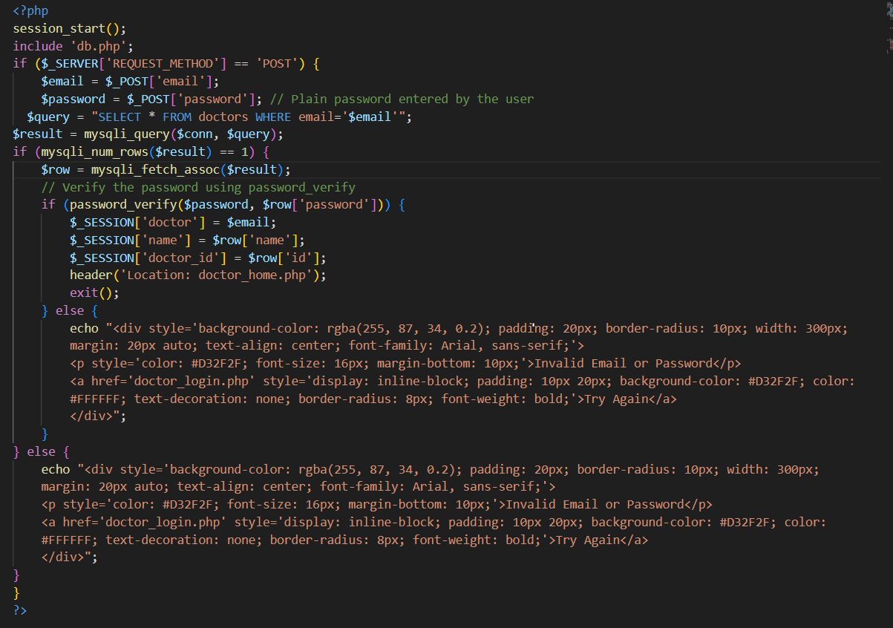

This PHP login script authenticates doctors by verifying their email and password. Upon successful login, it starts a session, storing the doctor's email, name, and ID, and redirects them to doctor_page.php. If authentication fails, it displays an error message with a styled "Try Again" link, guiding the doctor back to the login page for another attempt.

DOCTOR_FORM

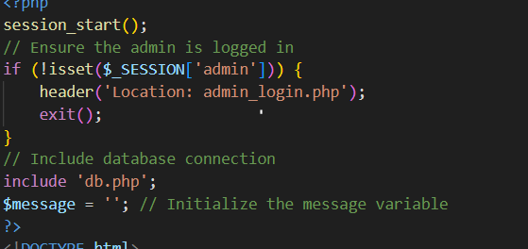

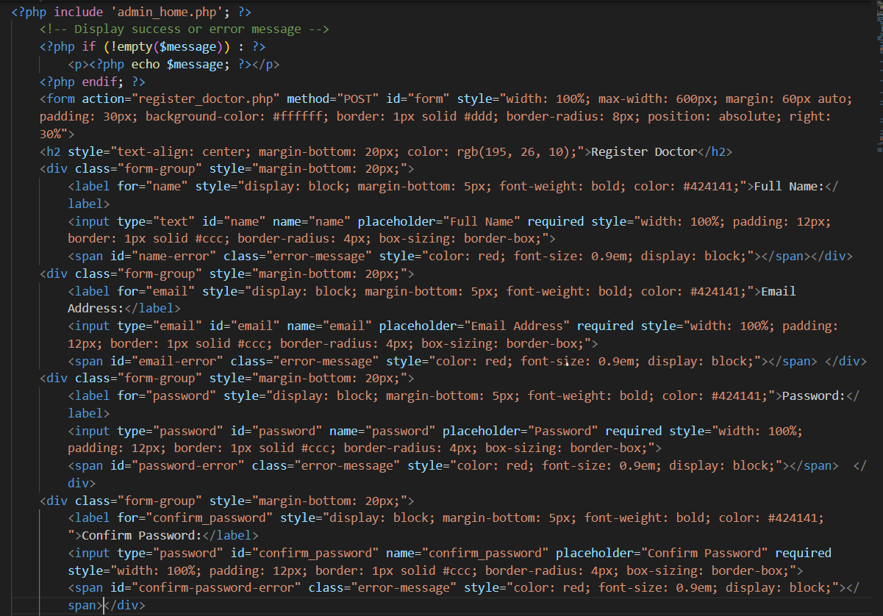

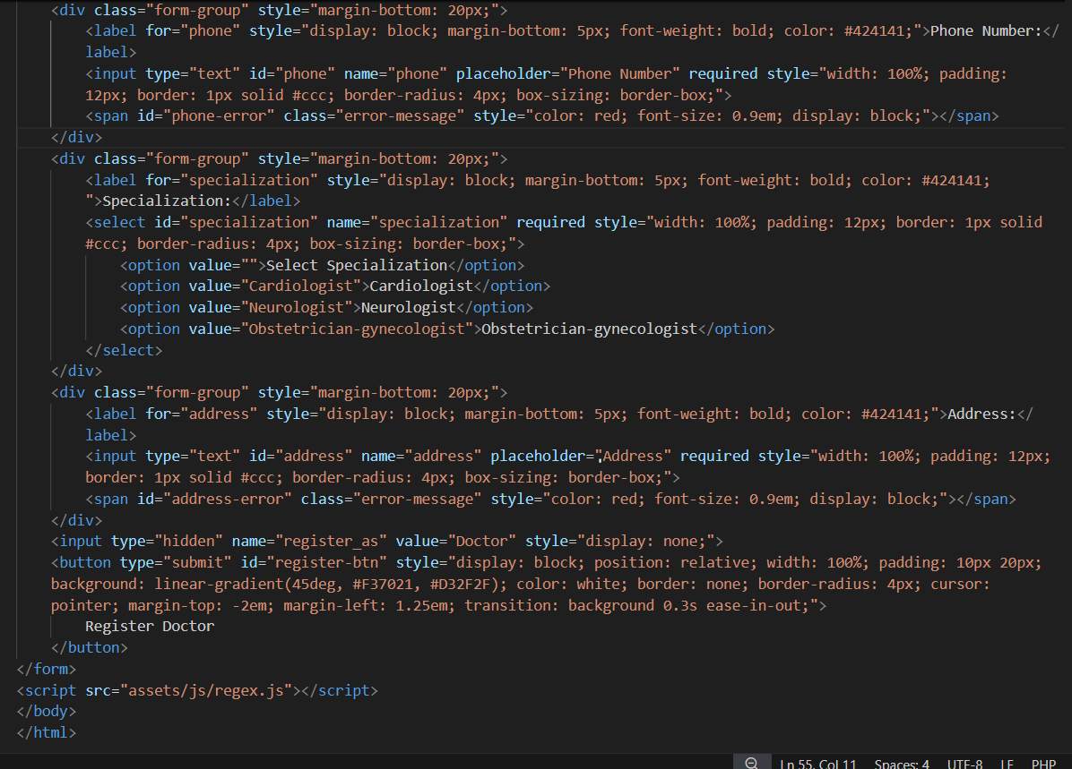

This PHP code creates a secure "Register Doctor" page, accessible only if an admin is logged in. It includes a registration form for doctors, capturing details such as name, email, password, phone, specialization, and address, with password confirmation. Upon submission, the form data is processed in register_doctor.php, while error and success messages display dynamically based on the result. The form layout is styled to ensure user-friendly input fields and visual feedback for form validation.

DOCTOR MANAGE_PATIENT

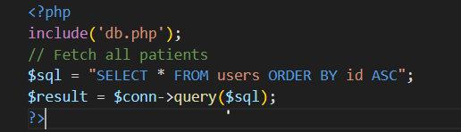

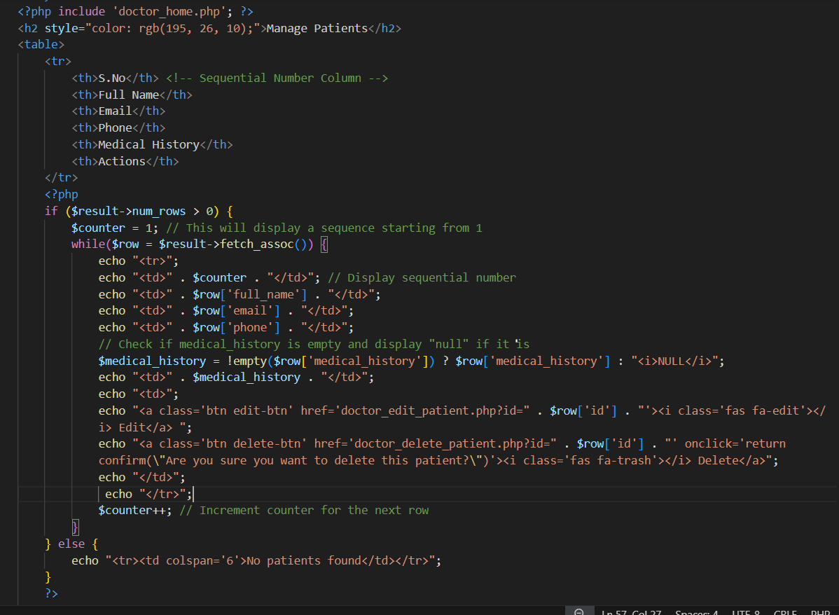

This PHP and HTML code displays a "Manage Patients" page in the doctor's panel, showing a table listing patients with details like full name, email, phone, and medical history. Each patient entry includes action buttons to edit or delete their records, with confirmation prompts for deletions. If no patients are found, a message is displayed indicating an empty table.

**DOCTOR DELETE_PATIENT**

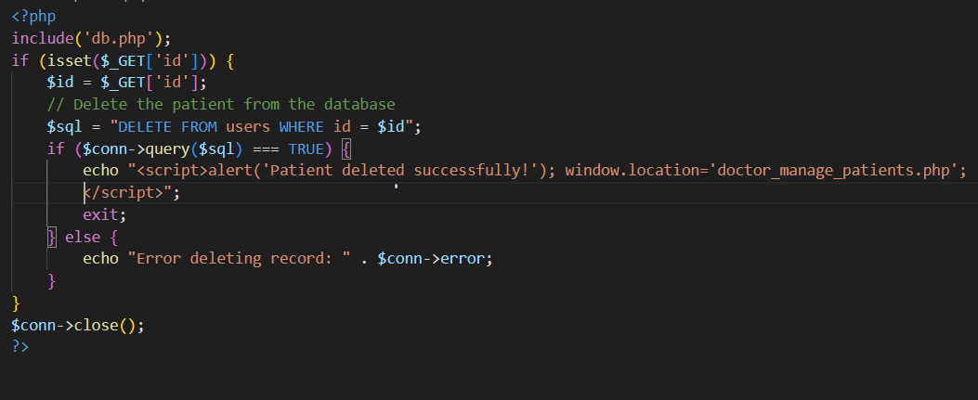

This PHP script deletes a patient record from the users table based on an ID passed via the GET method. If the deletion is successful, an alert notifies the user, and they are redirected to the doctor_manage_patients.php page. If an error occurs, it displays an error message with the database error details.

* DOCTOR EDIT_PATIENT

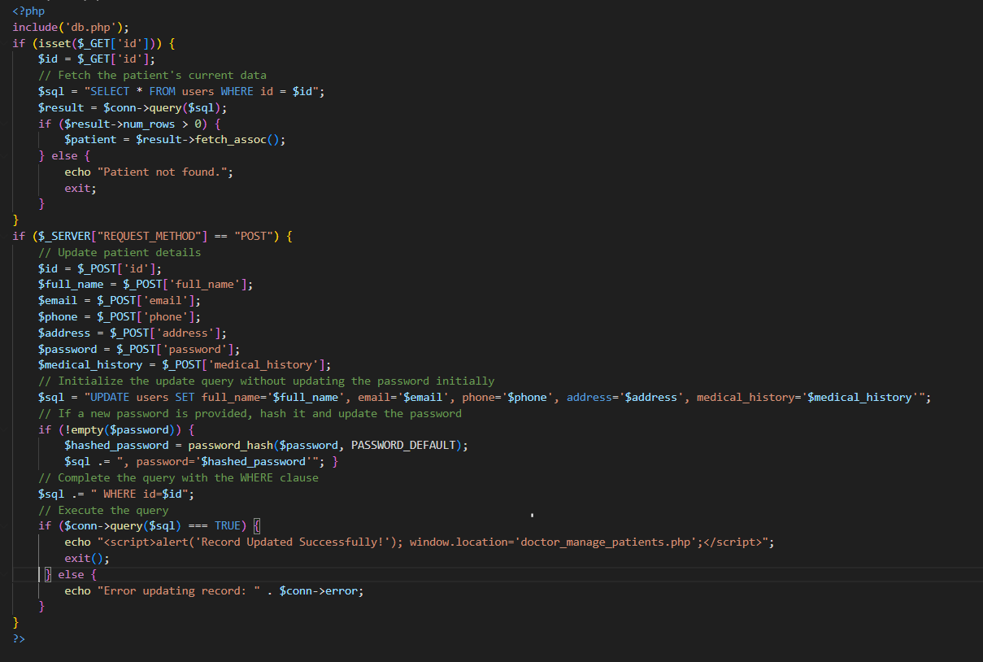

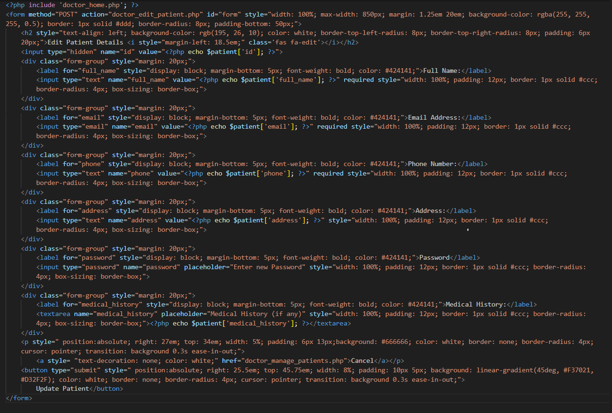

This PHP script allows a doctor to edit patient details by first retrieving the current patient information based on an ID and displaying it in an editable form. Upon submission, the updated information, including optional password changes (hashed if provided), is saved to the database. Success redirects the user to the "Manage Patients" page, with a cancel button to exit without changes.

DOCTOR UPDATE_PROFILE

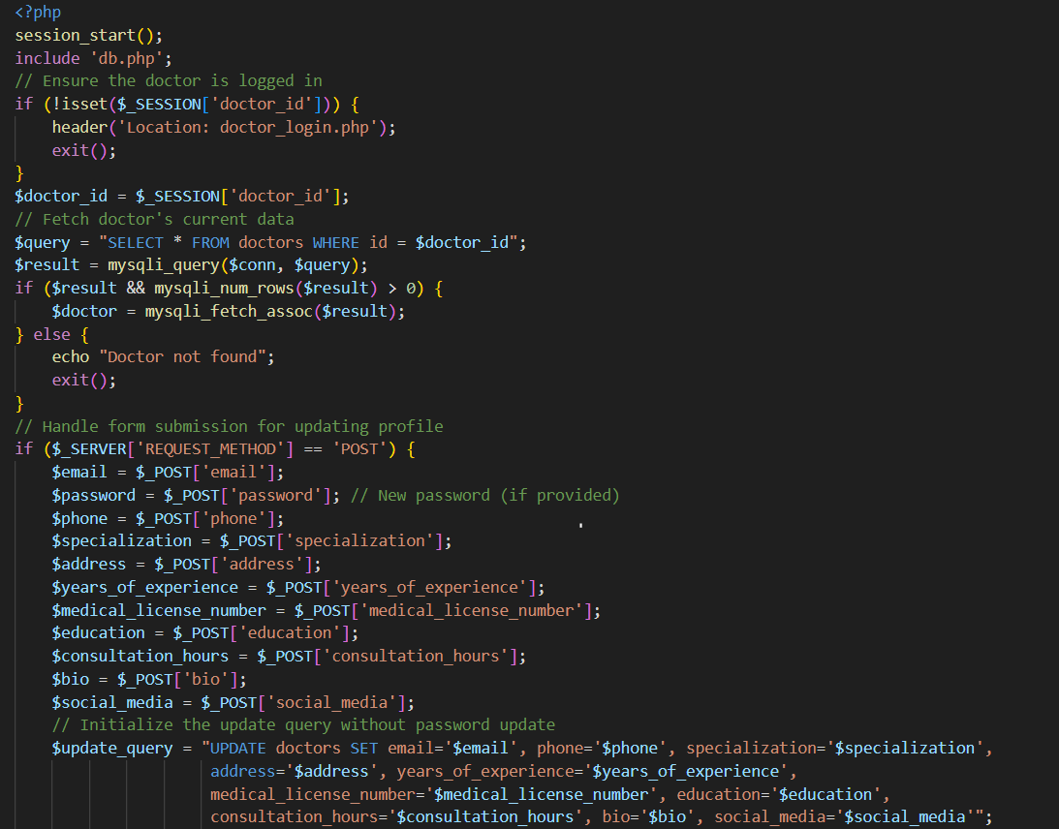

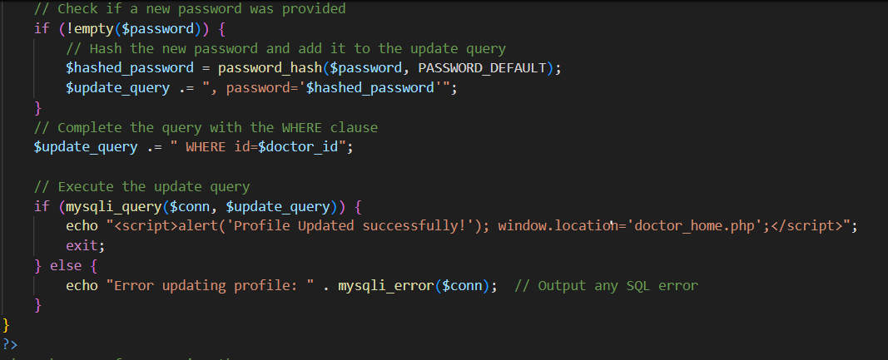

This PHP script manages the doctor’s profile update functionality. It begins by checking if the doctor is logged in; if not, it redirects to the login page. The script retrieves the doctor's current information from the database and displays it in a form for editing. Upon form submission, the updated details (including an optional new password) are saved back to the database, with a success message prompting a redirect to the doctor's main page.

DOCTOR VIEW_PROFILE

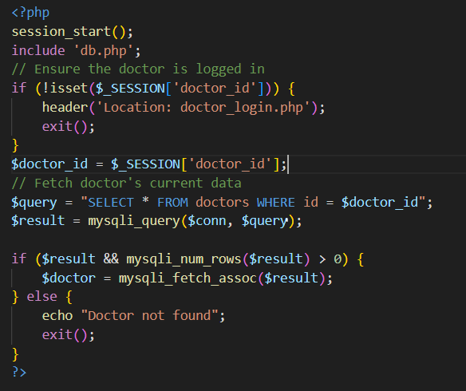

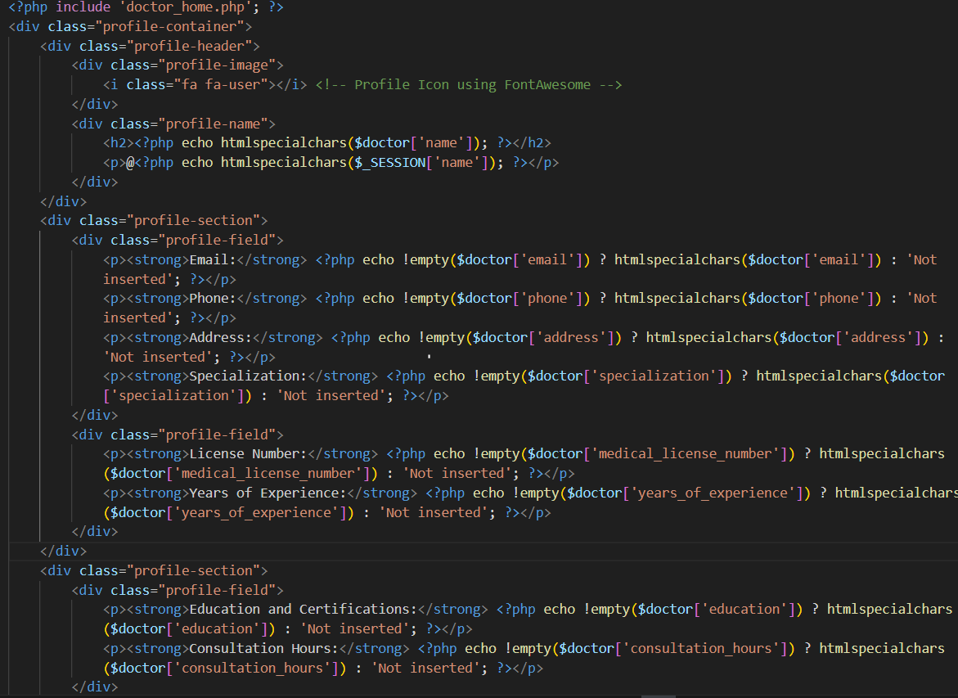

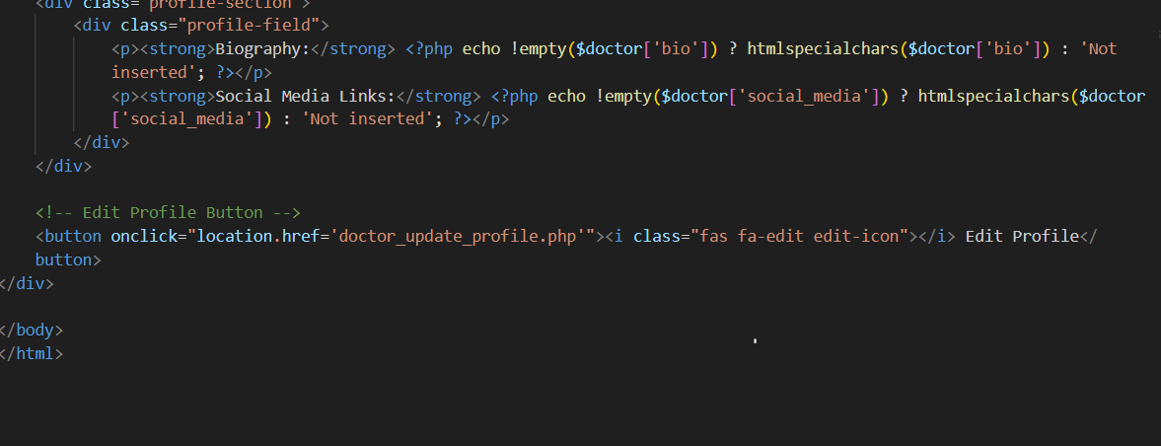

This PHP script allows a doctor to view their profile information after ensuring they are logged in. It retrieves the doctor's details from the database and displays them in a styled profile layout, including their name, contact information, specialization, experience, education, and a biography. The page also features an "Edit Profile" button that redirects the user to the profile update page for any modifications.

|  |  |  |  |  |  |  |
| --- | --- | --- | --- | --- | --- | --- |
| Project Ref. No.: eP/Advertisement Portal Management System/01 | | Project title | Date of Preparation of Activity Plan | | | |
| No | Task |  |  | Actual | Team-mate | Status |
| Start Date of project | Days | Names |
| 1 | Header and Banner ,Home page | 31/sep/2024 | 7 | Saba | Complete |
| 2 | Services page | “ | ***7*** | Syed Jawad | Complete |
|  | Contact us Page |  |  |  |  |
| 3 |  |  | “ | 10 | Anmol | Complete |
|  |  | Care managment  system |  |  |  |  |
| 4 | About us page | “ | 7 | Inshal mustufa | Complete |
| 5 | Faqs | “ | 7 | Sha mir hassan | Complete |
|  |  | “ |  |  |  |
| 6 | Admin login, register , logout, side pannel, admin register, Edit, delete doctor & patient |  |  | 15 | Hafsa | Complete |
|  |  |  |  |  |  |

|  |  |  |  |  |  |  |
| --- | --- | --- | --- | --- | --- | --- |
| No | Task |  |  | Actual | Team-mate | Status |
| Start Date of project | Days | Names |
| 7 | Doctor panel  Register, edit , delete, view profile (patient) | 31/sep/2024 | 7 | Hafsa | Complete |
| ***8*** | Disease section with database | “ | ***5*** | Saba | Complete |
|  | Search doctor, add availibility, book appointment |  |  |  |  |
| 9 |  |  | “ | 7 | Saba | Complete |
|  |  | Care managment  system |  |  |  |  |
| 10 | Add cities | “ | 5 | Anmol | Complete |
| 11 | User search Doctors | “ | 7 | Saba | Complete |
|  |  | “ |  |  |  |